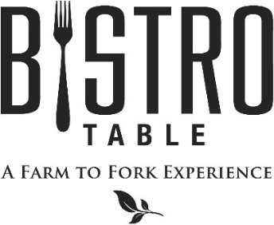

**What Makes Us Better and Different**

*Everything we prepare starts as real, whole food and we focus on the best, freshest available ingredients. That means that we work with those around us to find the foods that are at their peak. We look for organic and GMO-free. All of our Beef is Certified Black Angus, hand selected and aged for a minimum of 30 days, which naturally creates a deep rich flavor and considerably tenderer cut. Our Amish chicken is naturally raised from day 1, which means there are never any antibiotics, hormones, steroids, gluten, additives, or artificial ingredients introduced to the chicken. All of our Seafood is MSC certified, which is either wild caught or comes from an organic and sustainable fishery that manages and maintains the quality, structure, productivity, function and diversity of the ecosystem.*

**Starters**

**Jumbo Shrimp Cocktail\*** *with Classic Cocktail Sauce*

**Lump Crab and Avocado Crostini** *with Olive Oil and Lemon*

**Black Angus Beef Tartar** *with Garlic Aioli and Grilled Baguette*

**Pickled Beet Napoleon\*** *with Goat Cheese and Pistachio*

**Soups and Salads**

**Soup of the Day\*** *Composed Daily*

**Chestnut Soup***Creamy Chestnut Soup with Port Wine*

**Bistro Salad\*** *Mixed Greens, Goat Cheese, Mixed Berries, Walnuts and Raspberry Vinaigrette*

**Caesar Salad\*** *Romaine Lettuce, Challah Croutons, Three Cheese Blend and Anchovies*

**Shaved Brussels Sprout Salad** *with Apples, Cranberries and Red Wine Vinaigrette*

**Entrees**

**Bistro Surf & Turf**

*4 oz. Filet Mignon Paired with Canadian Lobster Tail, Served with*

*Yukon Gold Mashed Potatoes and Vegetable du Jour*

***Twin Tails always available***

**4 oz.* or 8 oz. Certified Black Angus Filet Mignon**

*Yukon Gold Mashed Potatoes, Vegetable du Jour, and Red Wine Demi-Glace*

**Garden Risotto\***

*Creamy Arborio Rice with Baby Spinach, Asparagus and Parmesan Cheese*

**Pan Seared Atlantic Sea Scallops**

*Lemon Butter Sauce with Lentils and Grilled Asparagus*

**Roasted Colorado Lamb Tenderloin**

*Fresh Horseradish Whipped Potatoes, Vegetable Du Jour and Mint Glace de Veau*

**Grilled Salmon\***

*Soy and Brown Sugar Glazed with Butter Roasted Sweet Potatoes and Jasmine Rice*

**Grilled 12 oz. Veal Porterhouse Steak**

*Whole Grain Mustard Creamed Spinach, Roasted Fingerling Potatoes, and Veal Demi-Glace*

**\*2 Point Meal Options**

**December 2019**

**Chef David Keefe**