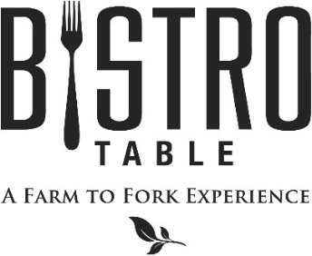
What Makes Us Better and Different
Everything we prepare starts as real, whole food and we focus on the best, freshest available ingredients. That means that we work with those around us to find the foods that are at their peak. We look for organic and GMO-free. All of our Beef is American, mid-western grain fed from northern cattle ranchers. Hand selected and aged for a minimum of 30 days, which naturally creates a deep rich flavor and considerably tenderer cut. Our Amish chicken is naturally raised from day 1, which means there are never any antibiotics, hormones, steroids, gluten, additives, or artificial ingredients introduced to the chicken. All of our Seafood is MSC certified, which is either wild caught or comes from an organic and sustainable fishery that manages and maintains the quality, structure, productivity, function and diversity of the ecosystem.
2 Point Meal: includes any one Starter, Soup, or Salad,
any one Entrée from the Farm to Fork Features or the 4oz Filet Mignon, and a Dessert.

3 Point Meal: includes any one Starter and one Soup or Salad,
any one Entrée, Sorbet, and a Dessert.

Starters

Jumbo Shrimp Cocktail with Classic Cocktail Sauce
Avocado Mash on Whole Grain Baguette
Crab Cake with Heirloom Tomatoes, Baby Spinach and Remoulade
Smoked Salmon and Cucumber with Lemon Dill Cream Cheese
Soups and Salads
Soup of the Day Composed Daily
Vichyssoise Chilled Potato and Leek Soup
Bistro Salad Mixed Greens, Goat Cheese, Mixed Berries, Walnuts and Raspberry Vinaigrette
Caesar Salad Romaine Lettuce, Challah Croutons, Parmigiano Reggiano and Anchovies
Burrata Salad Fresh Mozzarella, Heirloom Tomatoes, Mediterranean Greens,
Finished with Extra Virgin Olive Oil and Aged Balsamic
Entrees
Bistro Classics:
Bistro Surf & Turf
4 oz. Filet Mignon Paired with Canadian Lobster Tail Served with Yukon Gold Mashed Potatoes, Chef’s Vegetable du Jour
** Twin Tails always available**

4 oz. or 8 oz. Filet Mignon
Served with Yukon Gold Mashed Potatoes, Chef’s Vegetable du Jour, and Red Wine Demi-Glace

Grilled 14 oz. Black Angus Reserve Delmonico Steak with Truffle Butter, Yukon Gold Mashed Potatoes, Chef’s Vegetable du Jour

Farm to Fork Features:
Seared Sea Bass with Sautéed Broccolini, Farro, and Sauce Vierge
Bone-in Strip Steak with Roasted Fingerlings, Asparagus, and Charred Pepper Steak Sauce
Crab Cakes with Heirloom Tomatoes, Baby Spinach, and Remoulade
Braised Short Ribs with Jalapeño Cheddar Polenta and Roasted Brussels Sprouts
Roasted Duck Breast with Pickled Beets, Orange Supreme, Fingerlings, and Mixed Greens
Finished with a Rice Wine Vinaigrette

September 2018
Chef David Keefe

