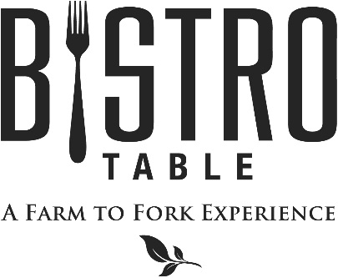
Starters

Jumbo Shrimp Cocktail with Customary Cocktail Sauce
Fried Oysters with Lemon and Chive Crème Fraîche
Roasted Bison Meatballs with Whole Grain Mustard Cream Sauce, Topped with Blue Affinee Cheese
Lively Run Goat Cheese Wontons with Candied Bacon and Scallions (2 Points)

Soups and Salads

Chef Doug’s Soup of the Day (2 Points)
or
French Onion Soup Topped with Gruyère Cheese

Bistro Salad Mixed Greens, Goat Cheese, Mixed Berries, Walnuts, and Raspberry Vinaigrette (2 Points)
Caesar Salad with Four Cheese Blend, Anchovies and Parmesan Crisp (2 Points)
Baby Kale & Roasted Butternut Squash with Grilled Red Onion, Dried Cranberries, and Balsamic Vinaigrette
Spinach Salad with Red Lion Cheddar Cheese and Warm Bacon & Maple Dressing

Main Course

All entrees are served with choice of Vegetable Du Jour, Grilled Asparagus, Haricot Vert, Sweet Potato & Bell Pepper Hash, Mashed Yukon Gold Potatoes, Roasted Fingerling Potatoes, or Wild Rice & Herbs

Bistro Classics

Bistro Surf & Turf
Petite Filet Mignon Paired with Canadian Lobster Tail
**Twin Tails always available**

8 oz. Filet Mignon
Topped with Blue Cheese Brûlée and Red Wine Demi-Glace

Petite Filet Mignon (2 Points)
Simply Grilled and served with Red Wine Demi-Glace

Farm to Fork Features

Veal Osso Buco with Root Vegetables and Braising Jus

Pan Seared Canadian Walleye with Lemon Caper Butter

Roasted Rack of Lamb Rubbed with Rosemary and Thyme

Cioppino Mussels, Shrimp, Clams, Scallops, Tomatoes, Garlic, and White Wine

Seared Pumpkin Gnocchi with Spinach and Beurre Noisette (2 Points)

Pan Roasted Quail Stuffed with Andouille and Cornbread (2 Points)

October 2017
Bistro Chef- Douglas Dake

