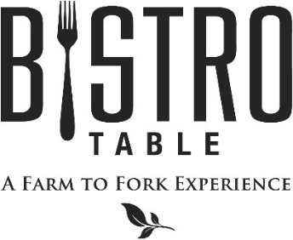

What Makes Us Better and Different
All of our Beef is American, mid-western grain fed from northern cattle ranchers. Hand selected and aged for a minimum of 30 days, which naturally creates a deep rich flavor and considerably tenderer cut. Our Amish chicken is naturally raised from day 1, which means there are never any antibiotics, hormones, steroids, gluten, additives, or artificial ingredients introduced to the chicken. All of our Seafood is MSC certified, which means you can be sure it is either wild caught or comes from an organic and sustainable fishery that manages and maintains the quality, structure, productivity, function and diversity of the ecosystem.
2 Point Meal: includes any one Starter, Soup, or Salad,
any one Entrée from the Farm to Fork Features or the 4oz Filet Mignon, and a Dessert.

3 Point Meal: includes any one Starter and one Soup or Salad,
any one Entrée, Sorbet, and a Dessert.

Starters

Jumbo Shrimp Cocktail with Customary Cocktail Sauce

Grilled Portobello with Roasted Red Pepper and Creamy Brie
Fresh Colossal Lump Crab with French Cocktail Sauce
Poutine Served with Fresh Cheese Curds and Beef Gravy

Soups and Salads

Soup of the Day
French Onion Soup Topped with Gruyère Cheese

Bistro Salad Mixed Greens, Goat Cheese, Mixed Berries, Walnuts, and Raspberry Vinaigrette
Caesar Salad with Four Cheese Blend, Anchovies and Parmesan Crisp
Joyce Farms Organic Chicken and Watercress Salad
with Toasted Pine Nuts and Blood Orange Vinaigrette

Entrees

Bistro Classics
Bistro Surf & Turf
4 oz. Filet Mignon Paired with Canadian Lobster Tail
**Twin Tails always available**

4 oz. or 8 oz. Filet Mignon
Served with Yukon Gold Mashed Potatoes, Chef’s Vegetable Du Jour, and Red Wine Demi-Glace

Rack of Lamb Persillade
Served with Yukon Gold Mashed Potatoes, Chef’s Vegetable Du Jour, and Mint Demi-Glace

Farm to Fork Features
Joyce Farms Oven Roasted Organic Chicken Breast
with Roasted Root Vegetables, Pearl Onions and Spiced Broth

Grilled Swordfish with Fingerling Potatoes, tossed with Arugula and Served with Lemon Beurre Blanc

Snake River Farms Kobe Steak Cast Iron Seared Kobe Culotte Steak, Jasmine Rice, Baby Bok Choy and Shaved Carrots, Finished with a Ginger and Lemon Grass Infused Glace de Viande

Herb Fettuccini Tossed with Roasted Butternut Squash, Arugula & Cranberries, in a Creamy Boursin Sauce

March 2018

