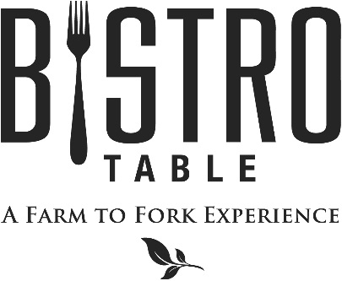
Starters

Jumbo Shrimp Cocktail with Customary Cocktail Sauce
Braised Pork Belly Braised in Root Beer with Napa Cabbage Slaw
Oysters Rockefeller topped with a rich sauce of Butter, Herbs, and Lemon
Arancini A rustic Italian Favorite, Served with our Marinara sauce for dipping (2 Points)

Soups and Salads

Chef Doug’s Soup of the Day (2 Points)
or
French Onion Soup Topped with Gruyère Cheese

Bistro Salad Mixed Greens, Goat Cheese, Mixed Berries, Walnuts, and Raspberry Vinaigrette (2 Points)
Caesar Salad with Four Cheese Blend, Anchovies and Parmesan Crisp (2 Points)
Harvest Kale Salad with Anjou Pears, Pecans, Stilton Cheese, and Concord Grape Vinaigrette
Cucumber Salad with Extra Virgin Olive Oil & Meyer Lemon Dressed Frisée, Tomato and Pickled Onion

Main Course

All entrees are served with choice of Rosemary, Parmesan & Black Truffle Pommes Frites, Vegetable Du Jour, Grilled Asparagus, Roasted Baby Button Mushrooms, Mashed Yukon Gold Potatoes or Wild Rice & Herbs

Bistro Classics

Bistro Surf & Turf
Petite Filet Mignon Paired with Canadian Lobster Tail
**Twin Tails always available**

8 oz. Filet Mignon
Topped with Crispy Shallots and served with Red Wine Demi-Glace

Petite Filet Mignon (2 Points)
Simply Grilled and served with Red Wine Demi-Glace

Farm to Fork Features

Panko Crusted Veal Cutlet with Arugula Salad and Roasted Pearl Onions (2 Points)

Haddock Filled with Maine Lobster and Crab

Shrimp and Asparagus Fettuccini with Roasted Garlic Cream Sauce (2 Points)

Pan Roasted Chilean Sea Bass with Fine Herb Butter

Braised Lamb Osso Buco with Creamy Polenta and Mushrooms

December 2017
Bistro Chef- Douglas Dake

