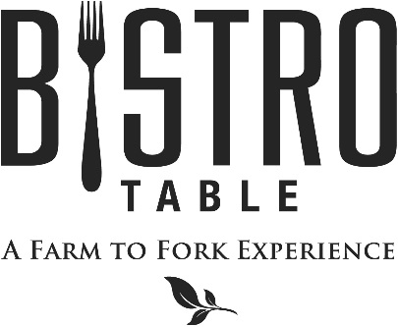
Starters

Jumbo Shrimp Cocktail Customary Cocktail Sauce
Clams Casino Baked Little Neck Clams Casino (2 Points)
Grilled Lamb Lollipops with Olive Tapenade and Grilled Baguette
Heirloom Tomato Crustad, Heirloom Tomato & Fresh Mozzarella Crustad w/ Fresh Basil (2 Points)

Soups and Salads
Chef Doug’s Soup of the Day (2 Points)
Or
French Onion Soup Topped with Gruyere Cheese

Caesar Salad Challah Bread Croutons, Four Cheese Blend, Anchovies, and Parmesan Crisp (2 Points)
Bistro Salad Spinach, Blue Cheese, Mixed Berries, Walnuts, and Raspberry Vinaigrette (2 Points)
Arugula Salad Grilled Peaches and Gorgonzola Finished with a Cherry Balsamic Reduction
Grilled Octopus Salad Blistered Grape Tomatoes, Olives, and Cipollini Onion
Tossed in a Lemon Thyme Vinaigrette

Main Course
All entrees are served with choice of Vegetable Du Jour, Grilled Asparagus, Broccolini, Wild Rice Blend
Boursin Mashed Potatoes, Roasted Fingerling Potatoes

Bistro Classics
Bistro Surf & Turf
Petite Filet Mignon Paired with Canadian Lobster Tail
**Twin Tails always available**

Filet Mignon
Topped with Blue Cheese Crumbles and Red Wine Demi-Glace, Haystack Fries

Petite Filet Mignon (2 Points)
Simply Grilled and served with Red Wine Demi-Glace

Farm to Fork Features
Orecchiette Bolognese (2 Points)
With Black Angus Beef Tips and Wild Mushrooms Finished with Shaved Parmigiano-Reggiano Cheese

Rack of Lamb Persillade
Rubbed with a Dijon and Fresh Herb Panko Finished with a Red Wine Glace D’Agneau

Pan Seared Chilean Sea Bass with Braised Greens and Crispy Pancetta

Pecan Crusted Faroe Island Salmon with Fresh Arugula and Tomato Salad (2 Points)

Sweet Soy Pork Tournedos with Napa Cabbage Slaw (2 Points)

Shrimp Scampi Farfalle Pasta Tossed with Tomato, Mushroom and White Wine Herb Sauce (2 Points)

Grilled 14 oz. Strip Steak Topped with Foie Gras Butter

May - 2017
Bistro Chef- Douglas Dake

