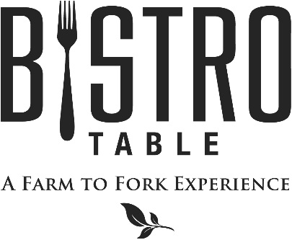
Starters

Jumbo Shrimp Cocktail Customary Cocktail Sauce
Jumbo Lump Crab Salad Lime and Butter Poached Jumbo Lump Crab and Micro Greens
Sautéed Gnocchi with Arugula & Crisp Pancetta, Grated Cheese, Fresh Cracked Pepper and Oil (2 Points)
Arancini Risotto Fritters with Pine Nuts & Parmesan, over Fresh Basil Marinara (2 Points)

Soups and Salads

Chef Doug’s Soup of the Day (2 Points)
Or
French Onion Soup Topped with Gruyere Cheese

Caesar Salad Challah Bread Croutons, Four Cheese Blend, Anchovies, and Parmesan Crisp (2 Points)
Bistro Salad Spinach, Blue Cheese, Mixed Berries, Walnuts, and Raspberry Vinaigrette (2 Points)
Watercress Salad Stone Fruit, Bermuda Onion & Gorgonzola, Finished with a Fresh Herb Vinaigrette
Vermicelli Salad with Cured Meats, Marinated Vegetables and Smoked Provolone

Main Course
All entrees are served with choice of Vegetable Du Jour, Grilled Asparagus, Summer Vegetable Medley, Orzo Pasta Salad, Boursin Mashed Potatoes, Grilled Red Bliss Potatoes

Bistro Classics
Bistro Surf & Turf
Petite Filet Mignon Paired with Canadian Lobster Tail
**Twin Tails always available**

Filet Mignon
Topped with Stilton Cheese Brûlée

Petite Filet Mignon (2 Points)
Simply Grilled and served with Red Wine Demi-Glace

Farm to Fork Features

Hybrid Striped Bass
With Roasted Corn and Tomato Salsa

Canadian Walleye
Finished with Embellishment Oil

Breaded Chicken Cutlet with Fresh Arugula, Radish Salad, Parmesan and Lemon Vinaigrette (2 Points)

Pan Seared Scallops with Coconut Jasmine Rice, Watermelon and Lime Beurre Blanc

Shrimp & Clam Linguini with Pittsford Dairy Cream, Heirloom Tomatoes and Sweet Peas (2 Points)

Coffee and Chili Rubbed Coulotte Steak with Aji Amarillo Mustard, Peppers and Onions (2 Points)

June - 2017
Bistro Chef- Douglas Dake

