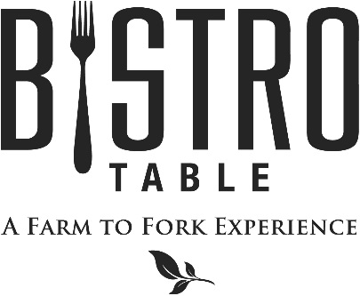
Starters

Jumbo Shrimp Cocktail Customary Cocktail Sauce
Oysters Rockefeller with Classic Hollandaise Sauce
Fried Green Tomatoes with Sweet Onion Jam (2 Points)
Pickled Beet Napolean with Lively Run Goat Cheese and Pistachio (2 Points)

Soups and Salads

Chef Doug’s Soup of the Day (2 Points)
Or
French Onion Soup Topped with Gruyere Cheese
Bistro Salad Mixed Greens, Goat Cheese, Mixed Berries, Walnuts, and Raspberry Vinaigrette (2 Points)
Caesar Salad with Four Cheese blend, Anchovies and Parmesan Crisp (2 Points)
Farro Tabbouleh with Heirloom Tomato, Baby Kale, Roasted Eggplant and Hummus
Grilled Peach with Arugula Salad, Maytag Blue Cheese and Red Onion

Main Course

All entrees are served with choice of Vegetable Du Jour, Grilled Asparagus, Roasted Cauliflower,
Dauphinoise Potatoes, Yukon Gold Mashed Potatoes, Roasted Fingerlings or Wild Rice Blend

Bistro Classics

Bistro Surf & Turf
Petite Filet Mignon Paired with Canadian Lobster Tail
**Twin Tails always available**

Filet Mignon
Topped with Blue Cheese Brûlée

Petite Filet Mignon (2 Points)
Simply Grilled and served with Red Wine Demi-Glace

Farm to Fork Features

Pan Roasted Corvina with Tarragon Butter (2 Points)

Rare Seared Ahi Tuna
With Udon Noodles and Miso

Bacon Wrapped Scallops
With Roasted Corn Salsa and Romesco Sauce

Cast Iron Seared Certified Angus Ribeye with Rosemary Mâitre d’Hotel Butter

Cheese Tortellini with Sundried Tomato, Fresh Basil Pesto (2 Points)

August 2017
Bistro Chef- Douglas Dake

