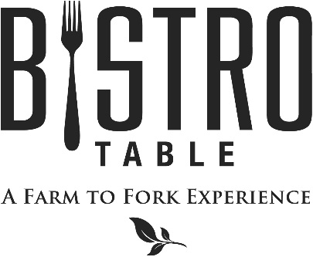
Starters

Jumbo Shrimp Cocktail Customary Cocktail Sauce
Fried Oysters Served with an Old Bay Infused Remoulade (2 points)
Crab and Corn Fritters with Lime Crème Fraîche (2 points)
Seared Ahi Tuna Over Watermelon Radish and Sweet Soy Drizzle

Soups and Salads
Chef Doug’s Soup of the Day (2 points)
Or
French Onion Soup Topped with Gruyère Cheese

Caesar Salad Challah Bread Croutons, Four Cheese Blend, Anchovies, and Parmesan Crisp (2 points)
Bistro Salad Spinach, Blue Cheese, Mixed Berries, Walnuts, and Raspberry Vinaigrette (2 points)
Pickled Beet Salad with Lively Run Goat Cheese, Candied Pecans, Orange Supremes, Aged Balsamic
Spinach and Applewood Smoked Bacon Salad with Roasted Tomato and Crispy Onion

Main Course
All entrees are served with choice of Vegetable Du Jour, Buttered Asparagus, Potato and Scallion Hash
Yukon Gold Mashed Potatoes, Wild Rice Blend, Haricot Vert

Bistro Classics
Bistro Surf & Turf
Petite Filet Mignon Paired with Canadian Lobster Tail
**Twin Tails always available**

Filet Mignon
Topped with Blue Cheese Crumbles and Red Wine Demi-Glace, Haystack Fries

Petite Filet Mignon (2 points)
Simply Grilled and served with Red Wine Demi-Glace

Farm to Fork Features
Idaho Rainbow Trout (2 points)
With Toasted Walnut Basmati Rice and Lemon Butter

Grilled Rosemary Rubbed Veal Chop
Served with Apple and Fennel Saute

Seafood Cioppino
Shrimp, Mussels, Clams, Lobster and Scallops in a Tomato and White Wine Broth

Oven Roasted Cornish Game Hen with Natural Jus Reduction

Pan Seared Snapper (2 points)
With Braised Swiss Chard and Roasted Cipollini Onions

Fresh Pappardelle Pasta (2 points) with Roasted Asparagus, Oven Roasted Tomato, Zucchini, Squash

April - 2017
Bistro Chef- Douglas Dake

