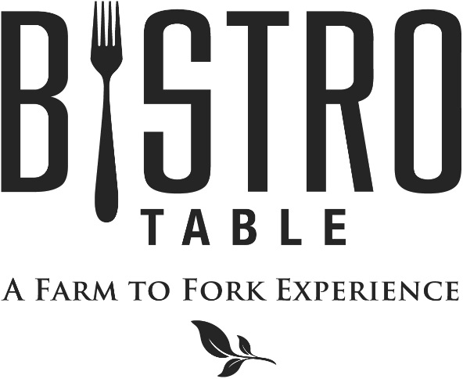

Soup Du Jour
Composed Daily

Highland Salad
Dried Cranberries, Candied Pecans, Diced Apple and Goat Cheese
with Grilled Chicken and Dressed with Celery Seed Vinaigrette

Grilled Shrimp Caesar
Baby Hearts of Romaine, Challah Croutons,
Parmigiano Reggiano, Anchovies, Caesar Dressing
and Choice of Grilled Shrimp or Chicken

Pineapple and Shrimp Salad
Grilled Herb Marinated Shrimp, Frisée Lettuce, Pickled Red Onions
and Sweet Soy Dressing

Grilled Ham and Smoked Mozzarella Melt
Grilled Italian Bread, Shaved Red Onion and Bistro Sauce

Highland BLT
Applewood Smoked Bacon, Mixed Greens, and Tomato

Turkey Club
Served on 12 Grain Wheat with Lettuce, Tomato and
Applewood Smoked Bacon

The Bistro Burger
New York Cheddar Cheese Curds, Caramelized Onion
and House-made BBQ Sauce

Pastrami Reuben
Swiss Cheese, 1000 Island Dressing,
Sauerkraut on Rye Bread

Fried Egg on Ciabatta
Curly Endive, Affine Blue Cheese, and Bacon Vinaigrette

Sides

Fresh Sliced Fruit
Sweet Potato Fries
Bistro Frites
Daily Side Salad

Bistro Chef
David Keefe

