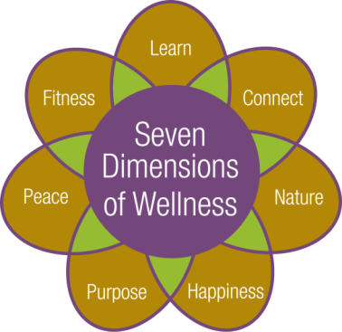



**Cultural and Educational**

**Program Calendar**

**September 2017**

**C:\Documents and Settings\memcdonald\Local Settings\Temporary Internet Files\Content.IE5\9FJ1V261\MC900359571[1].wmf**



**Friday September 1st**

9:00am – Fitness Class with Robin Gallagher. Hahnemann Club

10:15am – Fitness Class with Robin Gallagher. Fitness Room

11:15am – Tech Time with facilitator Cory White, IT Technician. Share ideas, information and questions about technology.Music Room

1:00pm~2:00pm – Open Swim with Robin Gallagher. Pool

**1:00pm – Catholic Mass with volunteers from St. Louis Church. Community Center**

**No *Pause for Peace* Service with Chaplin Jim Grobe today**

**2:30pm – Music Mixer, Entertainment with Larry Bitterman, vocalist/guitarist. Community Center**

**Saturday September 2nd:**

**No Tai Chi Class today**

11:00am – Trivia: Labor Day. Laurelwood Hearth Room

2:30pm – Saturday Musical Movie: Mamma Mia (2008) starring Meryl Streep, Pierce Brosnan

Sunday September 3rd:

10:30am – Communion Service with volunteers from St. Louis Church. Laurelwood Activity Room

2:30pm – Movie: *The Founder (2016)*, starring Michael Keaton, John Carroll Lynch and Nick Offerman. Community Center

3:00pm – Short Story: My Hilarious Job History. Laurelwood Hearth Room

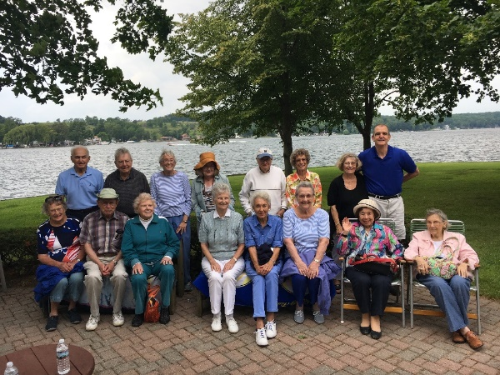

Picture: Residents enjoying the outdoors at Conesus Lake!!

**Monday September 4th: Labor Day**

**No Fitness Classes today**

**No Open Swim today**

1:00pm – Euchre Group. Social Room

7:00pm – Movie*: Newsies (1922)*, starring Christine Bale, David Moscow and Robert Duvall. Community Center

**-Stop by and see our Labor Day Tribute Display: Located in the Bistro Hallway-**

**Tuesday September 5th:**

9:00am & 10:00am – Depart for shopping and banking

**No water fitness today**

10:30am-12:00pm – Circuit Training On Your Own. Exercise Room

11:00am – Fitness Video. Fitness Room

1:15pm – Bible Study with Chaplain Jim Grobe. Laurelwood Gallery

**2:00pm – University of Rochester Course*: The Book of Genesis* with Anne Merideth, PhD, department of Religion and Classics at The University of Rochester. Please see page 14 for course information. Community Center**

**7:00pm – Game Night! Games are provided or bring your favorite game to share! Music Room**

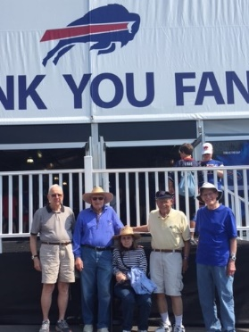

Picture: Residents at the Bills Training Camp at St. John Fisher College

From Left to Right: Allan Anderson, Ted Moore, Karen Moore, David Strong and Harry Carley

**Wednesday September 6th:**

9:00am – Fitness Class. Hahnemann Club

10:15am – Fitness Class. Fitness Room

**No Open Swim Today**

**\*10:30am** – **Depart for a trip to Skaneateles for lunch at Doug’s Fish Fry and shopping on Main St. Lunch will be ordered and paid for individually. Please note this trip requires a lot of walking.  Return at approx. 4:00pm.**

2:00pm – Pittsford Highlands Chorus practice. All are welcome to participate. Music Room

2:00pm – Fine Dining Food Forum. All are welcome to join to discuss your dining experience. Seneca Dining Room

4:30pm-6:00pm – Happy Hour: drink specials and appetizers. Highlands’ Pub

**7:00pm – Evening Music with Garry Scott on Piano. Laurelwood Gallery**

**Thursday September 7th:**

9:00am – Water Fitness with Robin Gallagher. Pool

9:00am & 10:00am – Depart for shopping and banking

10:30am-12:00pm – Circuit Training. Exercise Room

11:00am – Fitness Video. Fitness Room

2:00pm – Blood Pressure Screening. Club Room

**2:00pm – University of Rochester Course: *The New Sciences of the Human Mind*****with Brad Mahon PhD, department of Brain & Cognitive Sciences, Neurosurgery Department, Center for Visual Science and Center for Language Sciences at The University of Rochester. Please see page 14 for course information. Community Center**

**Friday September 8th:**

9:00am – Fitness Class with Robin Gallagher. Hahnemann Club

10:15am – Fitness Class with Robin Gallagher. Fitness Room

1:00pm-2:00pm – Open Swim with Robin Gallagher. Pool

1:00pm – Pause for Peace with Chaplain Jim Grobe. Music Room

**2:30pm – Music Mixer, Entertainment with Tom & Peg** **instrumental and vocal duo. Laurelwood Gallery**

3:30pm – Current Events Club. Are you interested in discussing current issues, expressing your opinions, and being exposed to the ideas of your fellow residents? Community Center

**Saturday September 9th:**

**9:00am-11:00am – Saturday Breakfast Guest Day: Grandparents Day Celebration, Dining**

**Room**

10:30am – Tai Chi & Qigong Class. Fitness Room

*11:00am – Pathway to Pittsford Errand Bus departs to Pittsford Plaza, Pittsford Cinema and Pittsford Community Library. The bus departs from the Highlands at 11:00am, 12:00pm and 1:00pm. Special Events: Pittsford Library Mini Book Sale and Main Street Pittsford Food Truck and Music Fest (Festival starts at noon).

2:30pm – Saturday Musical Movie: Yankee Doodle Dandy (1942) starring James Cagney Community Center

**Sunday September 10th: Grandparents’ Day**

10:30am – Communion Service with volunteers from St. Louis Church. Laurelwood Activity Room

1:30pm – Casual Bridge Game. All are welcome to join. Social Room

2:30pm – Movie: *Field of Dreams (1989)*, starring Kevin Costner and Amy Madigan. Community Center

**Monday September 11th: Patriot Day**

9:00am – Fitness Class with Robin Gallagher. Hahnemann Club

C:\Users\memcdonald\AppData\Local\Microsoft\Windows\Temporary Internet Files\Content.IE5\UG610O3Q\MP900384725[1].jpg**\*10:00am – Monthly Kitchen Tour, tour is approx. 30 minutes long. Space is limited; please sign up in the Program Book. Meet outside Lilac Shop**

10:15am – Fitness Class with Robin Gallagher. Fitness Room

1:00pm-2:00pm – Open Swim with Robin Gallagher. Pool

1:00pm – Euchre Group. Social Room

**2:00pm – Presentation: *Mennonite Culture in New York State and Throughout* *History* with Ivan Martin, Mary Ann Martin and Judson Reid. The guest speakers will speak about the Mennonite culture, as well as provide data, answer questions, and share their perspective. Community Center**

**Tuesday September 12th:**

9:00am – Water Fitness with Robin Gallagher. Pool

9:00am & 10:00am – Depart for shopping and banking

10:30am-12:00pm – Circuit Training. Exercise Room

11:00am – Fitness Video. Fitness Room

1:00pm – Knitting Group. Please bring your own supplies; yarn is available for charity

knitting. Music Room

**2:00pm – University of Rochester Course: *The Book of Genesis* with Anne Merideth, PhD, department of Religion and Classics at The University of Rochester. Please see page 14 for course information. Community Center**

**7:15pm – Depart for the Rochester Philharmonic Orchestra Concert: *Itzhak Perlman*. Please note transportation arrangements were made in advance. Return approx. 10:30pm**



**Wednesday September 13th:**

9:00am – Fitness Class with Robin Gallagher. Hahnemann Club

**\*9:30am** – **Depart for a shopping trip to the Waterloo Premium Outlet Mall.  Lunch will be on your own. Walking is required.  Return at approx. 4:00pm.**

10:15am – Fitness Class with Robin Gallagher. Fitness Room

1:00pm-2:00pm – Open Swim with Robin Gallagher. Pool

1:00pm –Alzheimer’s Support Group for caregivers facilitated by Alzheimer’s Association staff and volunteers. Seneca Dining Room

­­­1:15pm – Inspirational Hymns with Chaplin Jim Grobe. Laurelwood Gallery

2:00pm – Pittsford Highlands Chorus practice. All are welcome to participate. Music Room

4:30pm-6:00pm – Happy Hour: drink specials and appetizers. Highlands’ Pub

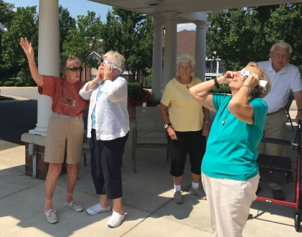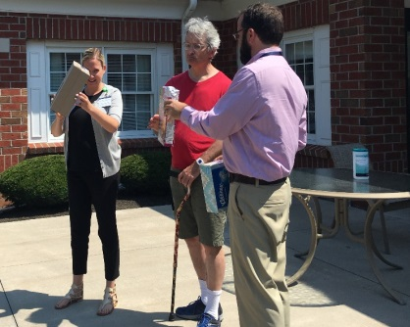

Pictures: Staff and Residents taking a look at the 2017 Solar Eclipse!

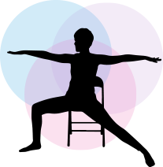**Thursday September 14th:**

9:00am – Water Fitness with Robin Gallagher. Pool

9:00am & 10:00am – Depart for shopping and banking

10:30am-12:00pm – Circuit Training. Exercise Room

11:00am – Fitness Video. Fitness Room

**\*1:00pm – Gentle Chair Yoga with Eva Kane. Fitness Room**

**2:00pm – University of Rochester Course: *The New Sciences of the Human Mind*****with Brad Mahon PhD, department of Brain & Cognitive Sciences, Neurosurgery Department, Center for Visual Science and Center for Language Sciences at The University of Rochester. Please see page 14 for course information. Community Center**

**Friday September 15th:**

9:00am – Fitness Class with Robin Gallagher. Hahnemann Club

10:15am – Fitness Class with Robin Gallagher. Fitness Room

11:15am – Tech Time with facilitator Cory White, IT Technician. Share ideas, information and questions about technology. Music Room

12:30pm~1:30pm Aquatic Exercise with Robin Gallager. Pool

**No Worship Service with Chaplain Jim Grobe today**

1:30pm-2:15pm – Open Swim with Robin Gallagher. Pool

**2:30pm – Music Mixer, Entertainment with Geoff Clough on keyboard. Community Center**

**7:15pm – Depart for the POPs Concert: *A cELLAbration: The Music of Ella & More.*  Please note transportation arrangements were made in advance. Return approx. 10:30pm**

**Saturday September 16th:**

10:30am – Tai Chi & Qigong Class. Fitness Room

11:00am – Trivia: What do you know? Laurelwood Hearth Room

2:30pm – Saturday Musical Movie: *On the Town (1949)*, starring Gene Kelly, Frank Sinatra, Jules Munshin and Betty Garrett. Community Center

Sunday September 17th:

10:30am – Communion Service with volunteers from St. Louis Church. Laurelwood Activity Room

11:00am – Trivia: What do you know? Laurelwood Hearth Room

2:30pm – Movie: *Julie and Julia (2009)*, starring Amy Adams and Meryl Streep, Community Center

**Monday September 18th:**

9:00am – Fitness Class with Robin Gallagher. Hahnemann Club

10:15am – Fitness Class with Robin Gallagher. Fitness Room

1:00pm-2:00pm – Open Swim with Robin Gallagher. Pool

1:00pm – Euchre Group. Social Room

**2:00pm – University of Rochester Course: *Stress Resilience:  Understanding the Mind-Body Connection for Healthy Aging* withKathi Heffner, PhD. Learn the scientific understanding of stress effects on health and new research aimed at promoting stress resilience to age well.   Please see page 16 for course information. Community Center**

**7:00pm – Join us for The Evening Exchange: Ted Talks: Nationalism VS Globalism: The New Political Divide. Community Center**

**Tuesday September 19th:**

9:00am – Water Fitness with Robin Gallagher. Pool

9:00am & 10:00am – Depart for shopping and banking

10:30am-12:00pm – Circuit Training. Exercise Room

11:00am – Fitness Video. Fitness Room

**\*11:15am – Depart for the Rochester Public Library Fall “Books Sandwiched In” Book Review: The Death and Life of the Great Lakes by Dan Egan. Reviewer: Veronica Volk, Great Lakes Reporter/Producer, WXXI News. Return approx. 1:30pm**

1:15pm – Bible Study with Chaplain Grobe. Laurelwood Gallery

**2:00pm – University of Rochester Course: *The Book of Genesis* with Anne Merideth, PhD, department of Religion and Classics at The University of Rochester. Please see page 14 for course information. Community Center**

**7:00pm – Game Night! Games are provided or bring your favorite game to share! Music Room**

**Wednesday September 20th: Rosh Hashanah begins at sundown**

9:00am – Fitness Class with Robin Gallagher. Hahnemann Club

10:15am – Fitness Class with Robin Gallagher. Fitness Room

1:00pm-2:00pm – Open Swim with Robin Gallagher. Pool

**\*1:00pm –** **Depart for the Antique Wireless Museum with a stop at Sharks Ice Cream in Bloomfield. Experience Two Centuries of Communication Technology. Exhibits include the voice of the first transistor radio, titanic radio room, the first cell phone and much much more. Admission fee is $7.00; fee will be collected on the bus. Return Approx. 4:00pm**

2:00pm – Pittsford Highlands Chorus practice. All are welcome to participate. Music Room

4:30pm-6:00pm – Happy Hour: drink specials and appetizers. Highlands’ Pub

**Thursday September 21st: First day of Autumn**

9:00am – Water Fitness with Robin Gallagher. Pool

9:00am & 10:00am – Depart for shopping and banking

10:30am-12:00pm – Circuit Training. Exercise Room

11:00am – Fitness Video. Fitness Room

11:00am – Pray the Rosary with volunteers from St. Louis Church. Community Center

**2:00pm – Presentation: Medicare 101, everything you need to know about Medicare while highlighting several points to aid in decision making. There will be a video and handouts, along with time to answers any questions. Community Center**

**2:00pm – Afternoon Music in Celebration of Rosh Hashanah with Susan Krasner, keyboard. Laurelwood Gallery**

2:00pm – Blood Pressure Screening. Club Room

**4:00pm** – **Rosh Hashanah Shofar Service with Rabbi Hein from Chabad-Lubavitch of Pittsford. Rabbi Hein will come and share some Jewish New Year inspiration and also sound a Shofar (Ram's horn) for the New Year. Music Room**

**6:30pm – Depart for the Rochester Philharmonic Orchestra Concert: Grieg’s Piano Concerto + Cinderella. Please note transportation arrangements were made in advance. Return approx. 10:00pm**

**Friday September 22rd:**

9:00am – Fitness Class with Robin Gallagher. Hahnemann Club

10:15am – Fitness Class with Robin Gallagher. Fitness Room

12:30pm-1:30pm – Aquatic Exercise with Robin Gallager. Pool

1:15pm – Worship Service with Chaplain Jim Grobe. Laurelwood Gallery

1:30pm-2:30pm – Open Swim with Robin Gallagher. Pool

**2:30pm – Music Mixer, Entertainment with duo Top Brass. Laurelwood Gallery**

3:30pm – Current Events Club. Are you interested in discussing current issues, expressing your opinions, and being exposed to the ideas of your fellow residents? Community Center

**Saturday September 23rd:**

10:30am – Tai Chi & Qigong Class. Fitness Room

**\*1:00pm-3:00pm – Harvest Festival: Enjoy activities with your grandchildren and great**

**grandchildren, music with Bill McDonald and the Old Hippies, playing country**

**and oldies mix, and light refreshments! Enjoy activities around the Highland**

**Campus**

2:30pm – Saturday Musical Movie: *Roberta (1935)*, starring Randolph Scott, Fred Astaire and Irene Dunne. Activities Room (Second Floor)

Sunday September 24th:

10:30am – Communion Service with volunteers from St. Louis Church. Laurelwood Activity Room

**\*12:45pm – Naples Grape Festival: Come and enjoy wine, food, arts, crafts and local/regional music. Sample everything "grape" that our valley has to offer. Return Approx. 5:00pm**

1:30pm – Casual Bridge Game. All are welcome to join. Social Room

2:30pm – Movie: *A Walk in the Woods (2015),* starring Robert Redford and Nick Nolte. Community Center

**Monday September 25th:**

9:00am – Fitness Class with Robin Gallagher. Hahnemann Club

**9:00am – Attracting Birds to Your Backyard and a Nature Walk. Liz Magnanti will teach you what birds we have in the area and how you can attract them to your yard!  There are simple things you can do to make your space a haven for wildlife. Small discussion on bird houses and nesting, different foods and feeders, using water, and more! Join us after for a nature walk. Bistro Patio (rain location: Laurelwood Hearth Room)**

10:15am – Fitness Class with Robin Gallagher. Fitness Room

**11:15am – Cultural Programming Meeting. Music Room**

1:00pm-2:00pm – Open Swim with Robin Gallagher. Pool

1:00pm – Euchre Group. Social Room

**2:00pm – Monthly Resident Meeting. Community Center**

**3:00pm~5:00pm – The Alzheimer's Association Presents, A Video Education Series: *Diagnosing and Treating Alzheimer's Disease* with David Gill, M.D. This interactive video education series will provide information on various topics as they relate to Alzheimer’s disease and other dementia. The sessions are intended to connect care partners with experts such as physicians, researchers, and attorneys. Music Room**

**Tuesday September 26th:**

9:00am – Water Fitness with Robin Gallagher. Pool

9:00am & 10:00am – Depart for shopping and banking

10:30am-12:00pm – Circuit Training. Exercise Room

11:00am – Fitness Video. Fitness Room

**1:00pm – Walking Club. Meet in Wellness Center**

1:15pm – Bible Study with Chaplain Jim Grobe. Laurelwood Gallery

**2:00pm – University of Rochester Course: *The Book of Genesis* with Anne Merideth, PhD, department of Religion and Classics at The University of Rochester. Please see page 14 for course information. Community Center**

2:00pm – Prayer Service with Chaplain Jim Grobe. Music Room

**7:00pm – Evening Music with Al Woy Onyx Clarinet Quartet. Community Center**

**Wednesday September 27th:**

9:00am – Fitness Class with Robin Gallagher. Hahnemann Club

10:15am – Fitness Class with Robin Gallagher. Fitness Room

1:00pm-2:00pm – Open Swim with Robin Gallagher. Pool

**\*1:30pm – Bus tour: More Mansions, Millionaires & Mendon with historian Warren Kling. Learn about the unique early history of Mendon & Honeoye Falls as we travel on the Indian trails of yesteryear, and find the connection to the wealthiest man of early Rochester. View many historic homes along our journey, along with other spectacular mansions and country estates. Discover who lives in these palatial estates.Return approx. 3:30pm. This tour will also be offered on Thursday, September 28th. Due to Popularity, please sign up for only one bus tour.**

2:00pm – Pittsford Highlands Chorus practice. All are welcome to participate. Music Room

4:30pm-6:00pm – Happy Hour: drink specials and appetizers. Highlands’ Pub

**Thursday September 28th:**

9:00am – Water Fitness with Robin Gallagher. Pool

9:00am & 10:00am – Depart for shopping and banking

10:30am-12:00pm – Circuit Training. Exercise Room

11:00am – Fitness Video. Fitness Room

**\*1:00pm – Gentle Chair Yoga with Eva Kane. Fitness Room**

**1:30pm – Presentation: *Music & Life of Kay Starr* by Larry Shearer. Laurelwood Activities Room**

**\*1:30pm – Bus tour: More Mansions, Millionaires & Mendon with historian Warren Kling. Learn about the unique early history of Mendon & Honeoye Falls as we travel on the Indian trails of yesteryear, and find the connection to the wealthiest man of early Rochester. View many historic homes along our journey, along with other spectacular mansions and country estates. Discover who lives in these palatial estates. Return approx. 3:30pm. This tour will also be offered on Wednesday September 27th. Due to Popularity, please sign up for only one bus tour.**

**\*2:30pm – Cooking Demonstration with Executive Chef Michael Wasylko.  Community Center**

**Friday September 29th:**

9:00am – Fitness Class with Robin Gallagher. Hahnemann Club

10:15am – Fitness Class with Robin Gallagher. Fitness Room

**\*1:00pm –Depart for Eastview Mall, Target and Victor Crossings where store selection includes Dollar Store, HomeGoods, Kohl’s, Wal-Mart, and PetSmart. Return approx. 4:00pm**

**1:15pm – Inspirational Hymn with Chaplain Jim Grobe. Laurelwood Gallery**

12:30pm~1:30pm – Aquatic Exercise with Robin Gallager. Pool

1:30pm-2:30pm – Open Swim with Robin Gallagher. Pool

**2:30pm – Music Mixer, Entertainment with Laura Dubin, jazz instrumental duo featuring drums and piano. Community Center**

**Saturday September 30th**

10:30am – Tai Chi & Qigong Class. Fitness Room

**\*11:00am – Pathway to Pittsford Errand Bus departs to Pittsford Plaza, Pittsford Cinema and Pittsford Community Library. The bus departs from the Highlands at 11:00am, 12:00pm and 1:00pm.**

2:30pm – Saturday Musical Movie: *Chicago (2002),* starring Catherine Zeta-Jones, Richard Gere and Renée Zellweger Community Center

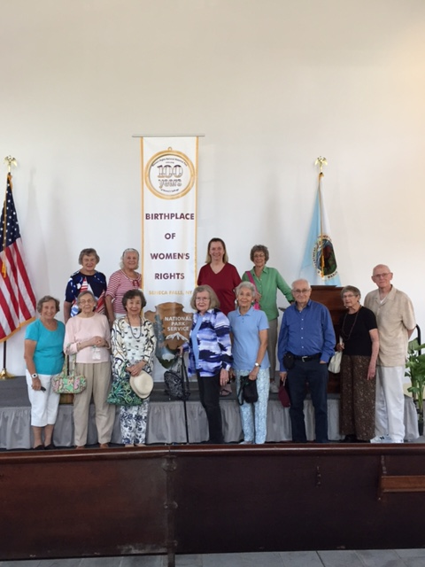

Picture: Residents Visiting Seneca Falls and the Women’s Rights National Historical Park. Left to Right: Nancy Robbins, Jackie Adams, Barbara Eltinge, Nancy Hare, June Mihalov, Mary Skews, Jean Chang, Barbara Harper, Gayle Ader, John Simonds, Jeanne and Harry Carley.

The Pittsford Highlands’ Chaplain, Jim Grobe, is available for one on one meeting. If interested please contact Elizabeth David

ext. 6344 and a date and time can be arranged.

**University of Rochester Course Description:**

**The Book of Genesis**

**Tuesdays September 5th – October 3rd at 2:00pm-3:00pm**

This course examines The Book of *Genesis* in order to examine not only the historical, religious, and social context of the text, but also to examine the ways in which the central themes in the narrative have reverberated throughout Jewish and Christian traditions and western civilization.  We will examine key texts such as creation, the flood and the Joseph narrative. Key topics such as the origins of humanity, the formation of Israel's religious and cultural identity, the role of women in Genesis.

Anne Merideth is a Senior Lecturer in Religion and Director of Undergraduate Studies for the Department of Religion and Classics at the University of Rochester. She received a master of theological studies from Harvard and PhD and masters from Princeton. She teaches a range of biblical topics, such as, women in the Bible, Biblical Economy, and Judaism in the Ancient World. She teaches with a historical and cultural perspective rather than from a theological perspective.

**The New Sciences of the Human Mind**

**Thursdays August. 31st —September 14th 2:00pm-3:00pm**

This course explores new technologies used to study the structure and organization of the

human mind and brain. In addition, review of recent advances that seek to improve treatments of common brain diseases will also be discussed.

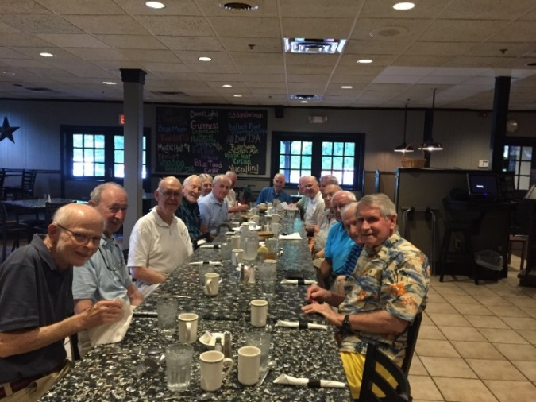Brad Mahon,Phd is a graduate from Harvard University, receiving his Masters in Cognitive Neuroscience in 2002 and Doctorate in 2009. He is presently an Assistant Professor in the Department of Brain & Cognitive Sciences, Neurosurgery Department, Center for Visual Science and Center for Language Science at The University of Rochester. Brad teaches undergraduate and graduate students on Cognitive Neuroscience, Plasticity, and Cognition.

Picture: Men's Thursday lunch group at

Mickey Finn's