

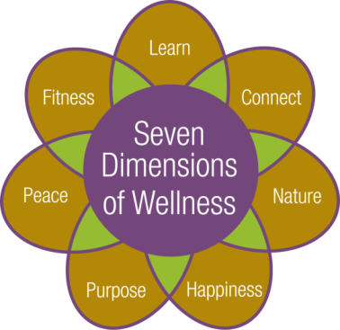

**Cultural and Educational Program Calendar**



**January 2018**

**C:\Users\memcdonald\AppData\Local\Microsoft\Windows\Temporary Internet Files\Content.IE5\R52BFS1F\MC900355771[1].wmf**













**Monday, January 1st: New Year’s Day**

**No Fitness Classes with Robin Gallagher today.**

**No Open Swim Today, pool is open, just need a buddy!**

1:00pm – Euchre Group. Social Room

7:00pm – Movie: New Year’s Day (1988) starring David Duchovny, and Milos Forman. Music Room



**Tuesday, January 2rd:**

9:00am – Water Fitness with Robin Gallagher. Pool

9:00am & 10:00am – Depart for shopping and banking

10:30am-12:00pm – Circuit Training. Exercise Room

11:00am – Fitness Video. Fitness Room

No Bible Study with Chaplain Jim Grobe today.

**2:00pm – University of Rochester Course: *Contemporary Chinese Popular Culture* with Ting Huang PhD., Senior Lecturer in Chinese Language at the University of Rochester. Please see page 14 for course information. Community Center**

**Wednesday, January 3rd:**

9:00am – Fitness Class with Robin Gallagher. Hahnemann Club

10:15am – Fitness Class with Robin Gallagher. Fitness Room

1:00pm-2:00pm – Open swim with Robin Gallagher. Pool

**\*1:00pm – Depart for a trip to the Eastman Theater. Enjoy a tour of some of the famous music halls known to the Rochester Area. Walking is required, No Fee. Return Approx. 4:00pm**

2:00pm – Pittsford Highlands Chorus practice. All are welcome to participate. Music Room

2:00pm – Fine Dining Food Forum. Seneca Dining Room

**4:30pm-6:00pm – Happy Hour: drink specials and appetizers. Highlands’ Pub. This month’s featured Artist is Sy Wiessman. In January we will display Sy’s photography. Please join us as we share his collection with you.**

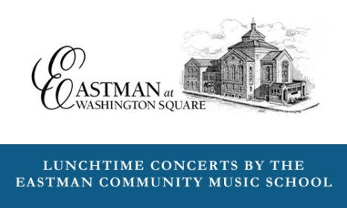**Thursday, January 4th:**

9:00am – Water Fitness with Robin Gallagher. Pool

9:00am & 10:00am – Depart for shopping and banking

10:30am-12:00pm – Circuit Training. Exercise Room

10:30am – Functional Fitness with Maureen Keller. Fitness Room

**\*11:30am – Eastman Concert at Washington Square Concert: *Twentieth Century Gems for Piano and Flute.* Performed by pianist Doug Hanson and Flutist Philip Nash. No fee to attend. Return approx. 1:30pm**

2:00pm – Blood Pressure Screenings. Club Room



**Friday, January 5th:**

9:00am – Fitness Class with Robin Gallagher. Hahnemann Club

10:15am – Fitness Class with Robin Gallagher. Fitness Room

11:15am – Tech Time with facilitator Crystal Rothfuss, IT Technician. Share ideas, information and questions about technology. Topic will be regarding *Texting vs. Messenger, what’s the difference?* Music Room

1:00pm – Catholic Mass with volunteers from St. Louis Church. Community Center

1:00pm – Pause for Peace with Chaplain Jim Grobe. Music Room

1:00pm-2:00pm – Open swim with Robin Gallagher. Pool

**2:30pm** – **Music Mixer, live entertainment duo with Dick Mazzatti. Community Center**

**Saturday, January 6th:**

10:30am – Tai Chi Class with Dr. Kathy Gill. Fitness Room

*11:00am – Pathway to Pittsford Errand Bus departs to Pittsford Plaza, Pittsford Cinema and Pittsford Community Library. The bus departs from the Highlands at 11:00am, 12:00pm and 1:00pm.

11:00am –Trivia: Laurelwood Hearth Room

2:30pm – Saturday Musical Movie: Singing in the Rain (1952) starring Gene Kelly, Donald O’Connor and Debbie Reynolds. Community Center

**Sunday, January 7th:**

10:30am – Communion Service with volunteers from St. Louis Church. Laurelwood Activity Room

11:00am – Trivia: What do you know? Laurelwood Hearth Room

2:30pm – Movie: Shall We Dance? (2004) starring Richard Gere, Jennifer Lopez and Susan Sarandon. Community Center

**Monday, January 8th:**

9:00am – Fitness Class with Robin Gallagher. Hahnemann Club

10:15am – Fitness Class with Robin Gallagher. Fitness Room

1:00pm – Euchre Group. Social Room

1:00pm-2:00pm – Open swim with Robin Gallagher. Pool

**2:00pm – Presentation: *The 3-R's of Recycling in Monroe County* with Tina Stevens, Environmental Educator at the Monroe County Department of Environmental Services. Does it go in the trash or recycling? Come to an informative presentation about recycling in Monroe County, and re-visit the 3-R's. Community Center**

**7:00pm – Monday Night Movie: Dunkirk (2017) starring Fionn Whitehead and Tom Glynn-Carney. Community Center**

**Tuesday, January 9th:**

9:00am – Water Fitness with Robin Gallagher. Pool

9:00am & 10:00am – Depart for shopping and banking

10:30am-12:00pm – Circuit Training. Exercise Room

10:30am – Functional Fitness with Maureen Keller. Fitness Room

**\*12:00pm – Pizza Party Luncheon. No fee to attend. Dining Room**

1:00pm – Knitting Group. Please bring your own supplies; yarn is available for charity knitting. Music Room

1:15pm – Bible Study with Chaplain Jim Grobe. Laurelwood Gallery

1:30pm –Book Discussion Group. All are welcome to join. Activities Room

**2:00pm – Travelogue Video: *The Barrier Reef: And Northeast Australia*, A Land of Natural Wonders. Community Center**

**7:00pm – Evening Music with Daniel Henry, jazz vocalist. Community Center**



**Wednesday, January 10th:**

9:00am – Fitness Class with Robin Gallagher. Hahnemann Club

10:15am – Fitness Class with Robin Gallagher. Fitness Room

**\*11:00am – Depart for lunch and tour at the Genesee Brewery. No fee for the tour. Return Approx. 2:30pm**

1:00pm – Alzheimer’s Support Group for caregivers facilitated by Alzheimer’s Association staff and volunteers. The group provides updated information, emotional support, and problem solving as related to the challenges of giving care to those living with Alzheimer’s disease or other dementia. Seneca Dining Room

1:00pm-2:00pm – Open swim with Robin Gallagher. Pool

2:00pm – Pittsford Highlands Chorus practice. All are welcome to participate. Music Room

4:30pm-6:00pm – Happy Hour: drink specials and appetizers. Highlands’ Pub

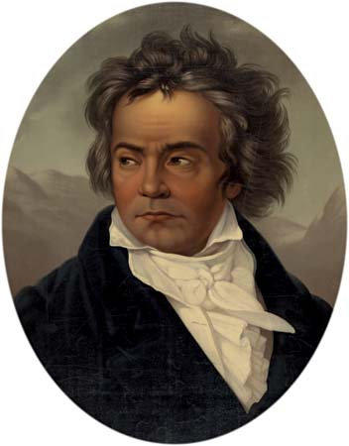**Thursday, January 11th:**

9:00am – Water Fitness with Robin Gallagher. Pool

9:00am & 10:00am – Depart for shopping and banking

10:30am-12:00pm – Circuit Training. Exercise Room

10:30am– Functional Fitness with Maureen Kellar. Fitness Room

**\*11:30am – Eastman Concert at Washington Square Concert: *Beethoven and Brahms.* Performed by violinist Karin Theobald, cellist Shade Zajac and pianists Belinda Cheng and Michelle Steffers. No fee to attend. Return approx. 1:30pm**

1:00pm – Gentle Chair Yoga with Eva Kane. Fitness Room

**2:00pm – Cooking Demo Food Discussion: Please join Director Dan Fernandes and Head Chef Michael Wasylko to discuss your ideas and experiences for our Cooking Demonstration programs. Music Room**



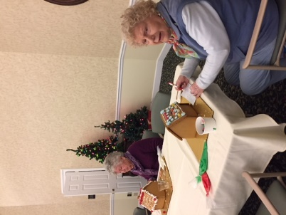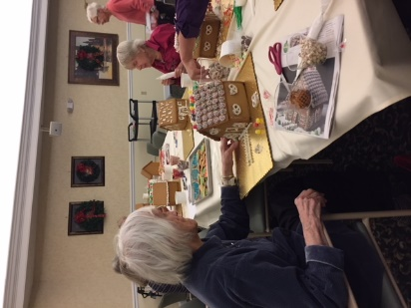

Residents Barbara Harper, Therese Lynch, Ginny Skuse, Ginny Peterssen and Eileen Schnier decorating gingerbread houses.

**Friday, January 12th:**

9:00am – Fitness Class with Robin Gallagher. Hahnemann Club

10:15am – Fitness Class with Robin Gallagher. Fitness Room

1:00pm-2:00pm – Open swim with Robin Gallagher. Pool

**\*1:00pm – Shopping at Victor Crossings Plaza, Eastview Mall or Target. Store selection includes: Dollar Store, HomeGoods, Wal-Mart, Kohl’s, and PetSmart. Return approx. 4:00pm**

1:15pm – Inspirational Hymns with Chaplain Jim Grobe. Music Room

**2:30pm** – **Music Mixer, live entertainment with** **Kit Nelson on guitar and vocals. Laurelwood Gallery**

3:30pm – Current Events Club. Are you interested in discussing current issues, expressing your opinions, and being exposed to the ideas of your fellow residents? Music Room

**Saturday, January 13th:**

10:30am – Tai Chi Class with Dr. Kathy Gill. Fitness Room

11:00am – Trivia: Laurelwood Hearth Room

1:00pm – Casual Bridge Game. All are welcome to join. Social Room

2:30pm – Saturday Musical Movie: Annie (1999) starring Alicia Morton, Kathy Bates, Victor Garber and Alan Cumming. Community Center

**Sunday, January 14th:**

10:30am – Communion Service with volunteers from St. Louis Church. Laurelwood Activity Room

11:00am – Trivia: What do you know? Laurelwood Hearth Room

1:30pm – Casual Bridge Game. All are welcome to join. Social Room

2:30pm – Movie: Andersonville (1996) starring Jarrod Emick, Frederic Forrest and Ted Marcoux. Community Center

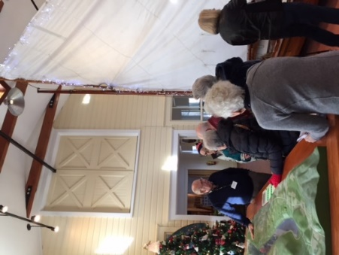

Residents enjoying a tour of the Skaneateles

Historical Society Museum at the Creamery.

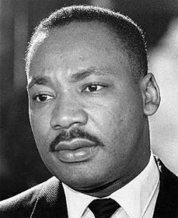**Monday, January 15th: Martin Luther King Jr. Day**

9:00am – Fitness Class with Robin Gallagher. Hahnemann Club

10:15am – Fitness Class with Robin Gallagher. Fitness Room

1:00pm – Euchre Group. Social Room

1:00pm-2:00pm – Open swim with Robin Gallagher. Pool

**2:00pm – Presentation: *Portrayal of Clara Barton* with Eleanor Stearns a historical actor. Eleanor will give a glimpses of her life, her involvement during the Civil War, and her role in the founding and activities of the American Red Cross. Community Center**

**3:00pm-4:00pm – iPhone/iPad Class with Crystal Rothfuss, IT Technician. Session will offer instruction on the use of iPhones and iPads. There will be a brief instructional “how to” on these devices. Please bring your devices with you. Music Room**

**\*7:00pm – Depart for Flower City Jazz Society Concert ­­­­. Tickets are $12.00 each, pay upon arrival. Return approximately 10:00pm. Title will be updated in the program book when it becomes available.**

**Tuesday, January 16th:**

9:00am – Water Fitness with Robin Gallagher. Pool

9:00am & 10:00am – Depart for shopping and banking

10:30am-12:00pm – Circuit Training. Exercise Room

10:30am – Functional Fitness with Maureen Kellar. Fitness Room

**\*12:30pm – Movie at Pittsford Cinema: The *Post.* A 2017 American**[**historical drama**](https://en.wikipedia.org/wiki/Historical_period_drama)[**political thriller**](https://en.wikipedia.org/wiki/Political_thriller)**directed and produced by**[**Steven Spielberg**](https://en.wikipedia.org/wiki/Steven_Spielberg)**. Set in the early 1970s, the film stars**[**Meryl Streep**](https://en.wikipedia.org/wiki/Meryl_Streep) **and** [**Tom Hanks**](https://en.wikipedia.org/wiki/Tom_Hanks)**. *The Post* depicts journalists from The Washington Post and The New York Times who published the**[**Pentagon Papers**](https://en.wikipedia.org/wiki/Pentagon_Papers)**regarding the involvement of the United States government during the**[**Vietnam War**](https://en.wikipedia.org/wiki/Vietnam_War). **Please be aware departure time may change. Admission fee is $6.75, paid at the theatre. Return approx. 3:30pm**

1:15pm – Bible Study with Chaplain Jim Grobe. Laurelwood Gallery

**7:00pm – Game Night! Games are provided or bring your favorite game to share! Music Room**



**Wednesday, January 17th:**

9:00am – Fitness Class with Robin Gallagher. Hahnemann Club

10:15am – Fitness Class with Robin Gallagher. Fitness Room

**\*11:00am – Depart for Del Lago Resort & Casino. Lunch at the Farmers Market Buffett, $15.95 per person, will be paid at the restaurant. Return Approx. 4:00pm.**

1:00pm-2:00pm – Open swim with Robin Gallagher. Pool

2:00pm – Pittsford Highlands Chorus practice. All are welcome to participate. Music Room

4:30pm-6:00pm – Happy Hour: drink specials and appetizers. Highlands’ Pub

**Thursday, January 18th:**

9:00am – Water Fitness with Robin Gallagher. Pool

9:00am & 10:00am – Depart for shopping and banking

*10:00am-1:00pm –Parkinson Café, a program designed to provide social, cultural, and intellectual interaction for people with Parkinson’s disease and their care partners.  A light lunch will be provided at no cost.  A donation of at least $2 per person is requested, as this is being provided by both The Highlands and National Parkinson’s Foundation.  Located at the Hahnemann Club, please request transportation.

10:30am– Functional Fitness with Maureen Kellar. Fitness Room

10:30am-12:00pm – Circuit Training. Exercise Room

11:00am – Pray the Rosary with volunteers from St. Louis Church. Music Room

2:00pm – Blood Pressure Screenings. Club Room

**2:00pm – Presentation: *Get Smart: Don’t Get Scammed* with Jim Lynd of Lifespan. Learn how to identify scams and ways to protect your information from telemarketers, scammers and more. Community Center**

**\*4:00pm – “UR” In Tune lecture titled: *Drumming Through the Ages* with John Beck, Professor/Emeritus of Percussion at the Eastman School of Music. Please see page 14 for course information. Community Center.**

**6:30pm – Depart for Rochester Philharmonic Orchestra Concert: *Night on Bald Mountain.* Please note transportation arrangements were made in advance. Return approx. 10:00pm**

**Friday, January 19th:**

9:00am – Fitness Class with Robin Gallagher. Hahnemann Club

10:15am – Fitness Class with Robin Gallagher. Fitness Room

11:15am – Tech Time with facilitator Crystal Rothfuss, IT Technician. Share ideas, information and questions about technology. Discussion Topic: *Snapchat, what is it?* Music Room

1:00pm-2:00pm – Open swim with Robin Gallagher. Pool

1:15pm – Worship Service with Chaplain Jim Grobe. Laurelwood Gallery

**2:30pm – Music Mixer, live jazz entertainment duo with Seth Sealfon. Community Center**

**Saturday, January 20th:**

10:30am – Tai Chi Class with Dr. Kathy Gill. Fitness Room

*11:00am – Pathway to Pittsford Errand Bus departs to Pittsford Plaza, Pittsford Cinema and Pittsford Community Library. The bus departs from the Highlands at 11:00am, 12:00pm and 1:00pm.

2:30pm – Saturday Musical Movie: 42nd Street (1933) starring Warner Baxter, Bebe Daniels and George Brent. Community Center

**Sunday, January 21st:**

10:30am – Communion Service with volunteers from St. Louis Church. Laurelwood Activity Room

1:30pm – Afternoon Music: Pittsford Community Church. Community Center

2:30pm – Movie: Florence Foster Jenkins (2016) starring Meryl Streep, Hugh Grant and Simon Helberg**.** Music Room

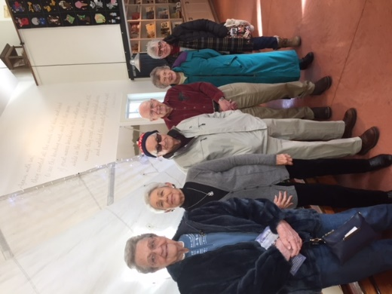

Residents Mary Jane Henderson, Gayle Ader, John Simonds, Al Lorenzo, Nancy Robbins and Cora Bartosch at the Museum at the Creamery.

**Monday, January 22nd:**

9:00am – Fitness Class with Robin Gallagher. Hahnemann Club

10:15am – Fitness Class with Robin Gallagher. Fitness Room

1:00pm – Euchre Group. Social Room

1:00pm-2:00pm – Open swim with Robin Gallagher. Pool

**2:00pm – Presentation: Better Brains: *10 Steps For Reversing Memory Loss* with Cornelia Lenherr. MD. Are you having trouble finding your keys?  Can’t remember names?  Do you walk into a room and forget why? Join Dr. Cory Lenherr for an introduction on brain health, causes of memory loss and cognitive impairment and what you can do to prevent and potentially reverse these changes. Community Center**

**Tuesday, January 23rd:**

9:00am – Water Fitness with Robin Gallagher. Pool

9:00am & 10:00am – Depart for shopping and banking

10:30am – Functional Fitness with Maureen Keller. Fitness Room

10:30am-12:00pm – Circuit Training. Exercise Room

1:00pm – Walking Club. Meet in the Wellness Center

1:15pm – Bible Study with Chaplain Jim Grobe. Laurelwood Gallery

2:00pm – Prayer Service with Chaplain Jim Grobe. Music Room

**2:00pm – Presentation: *Pilgrimage to Israel and Palestine* with resident Betty Iwan. Come learn about her journey with a small group from Colgate Rochester Crozer Divinity School in 2015 that included ancient and contemporary sites in Jerusalem, Bethlehem, Hebron, Qumran, Masada and the Galilee.** **Community Center**

**6:30pm – Evening Music with Mike Kornrich on guitar and vocals. Laurelwood Gallery**

The Pittsford Highlands’ Chaplain, Jim Grobe, is available for one on one meetings. If interested, please contact Elizabeth David ext. 6344 and a date and time can be arranged.

**Wednesday, January 24th:**

9:00am – Fitness Class with Robin Gallagher. Hahnemann Club

10:15am – Fitness Class with Robin Gallagher. Fitness Room

1:00pm-2:00pm – Open swim with Robin Gallagher. Pool

**\*1:00pm – Depart for a tour of the Special Touch Bakery. Enjoy the smells and smiles that Special Touch has to offer, along with bringing home a sweet treat from their store. Special Touch Bakery is affiliated with The School of the Holy Childhood. Walking is required, no fee to attend. Return Approx. 4:00pm.**

2:00pm – Pittsford Highlands Chorus practice. All are welcome to participate. Music Room

4:30pm-6:00pm – Happy Hour: drink specials and appetizers. Highlands’ Pub

**Thursday, January 25th:**

9:00am – Water Fitness with Robin Gallagher. Pool

9:00am & 10:00am – Depart for shopping and banking

10:30am-12:00pm – Circuit Training. Exercise Room

10:30am – Functional Fitness with Maureen Keller. Fitness Room

**\*11:30am – Enjoy a Greek lunch at a local dive on Park Avenue, Jines Restaurant. Experience some delicious Greek dishes such as spanakopita, and baba ganoush. Return Approx. 2:30pm**

1:00pm – Gentle Chair Yoga with Eva Kane. Fitness Room

**\*2:00pm –Hands-On Baking Class: Decorating holiday pastries with Pastry Chef Laura Gilbert. Community Center**

**2:30pm – Presentation: *Music and Life of Artie Shaw* with Larry Shearer. Laurelwood Activities Room**

**Friday, January 26th:**

9:00am – Fitness Class with Robin Gallagher. Hahnemann Club

10:15am – Fitness Class with Robin Gallagher. Fitness Room

1:00pm-2:00pm – Open swim with Robin Gallagher. Pool

1:15pm –Inspirational Hymns with Chaplain Jim Grobe. Music Room

**2:30pm – Music Mixer, live jazz duo on piano and drums with Laura Dubin. Community Center**

3:30pm – Current Events Club. Are you interested in discussing current issues, expressing your opinions, and being exposed to the ideas of your fellow residents? Music Room

**Saturday, January 27th:**

10:30am – Tai Chi Class with Dr. Kathy Gill. Fitness Room

11:00am – Trivia: Laurelwood Hearth Room

2:30pm – Saturday Musical Movie: Bette Midler: The Showgirl Must Go On (2010) starring Bette Midler. Community Center

**Sunday, January 28th:**

10:30am – Communion Service with volunteers from St. Louis Church. Laurelwood Activity Room

**1:30pm – Afternoon Music recital with school age children form 12-15 yrs. of age, featuring Cheryl Frank on Piano. Community Center**

1:30pm – Casual Bridge Game. All are welcome to join. Social Room

2:30pm – Movie: Titanic (1997) starring Leonardo DiCaprio, Kate Winslet, Billy Zane and Kathy Bates. Community Center

**Monday, January 29th:**

9:00am – Fitness Class with Robin Gallagher. Hahnemann Club

10:15am – Fitness Class with Robin Gallagher. Fitness Room

11:15am – Cultural Programming Meeting. All are welcome to join to discuss programming suggestions. Music Room

1:00pm – Euchre Group. Social Room

1:00pm-2:00pm – Open swim with Robin Gallagher. Pool

**2:00pm – Monthly Resident Meeting. Community Center**

**3:00pm – Winter Social: Come enjoy each other’s company while enjoying refreshments. Music Room**



**Tuesday, January 30th:**

9:00am – Water Fitness with Robin Gallagher. Pool

9:00am & 10:00am – Depart for shopping and banking

10:30am-12:00pm – Circuit Training. Exercise Room

10:30 – Functional Fitness. Fitness Room

1:15pm – Bible Study with Chaplain Jim Grobe. Laurelwood Gallery

**2:00pm – Presentation: *The Titanic: A Cultural Phenomenon* with Steve Piper, a** **member of the Titanic Historical Society. Learn why people are so obsessed with the Titanic. Could it have been prevented? Explore other catastrophes that have happened around the world, and why people are still so enamored with the Titanic? Community Center**

**7:00pm – Game Night! Games are provided or bring your favorite game to share! Music Room**

**Wednesday, January 31st:**

9:00am – Fitness Class with Robin Gallagher. Hahnemann Club

10:15am – Fitness Class with Robin Gallagher. Fitness Room

**11:00am – *Winter Concert Performance:* Chorus students from Park Road Elementary School. Community Center**

1:00pm-2:00pm – Open swim with Robin Gallagher. Pool

**1:15pm – Depart for Geva Theatre: *The Other Josh Cohen.* Please note transportation arrangements were made in advance. Return approx. 5:00pm**

2:00pm – Pittsford Highlands Chorus practice. All are welcome to participate. Music Room

**4:30pm-6:00pm – Happy Hour: drink specials and appetizers. Join us for our Unique Holiday Sweater happy hour. Enjoy a remix of holiday music and spirit. Highlands’ Pub**

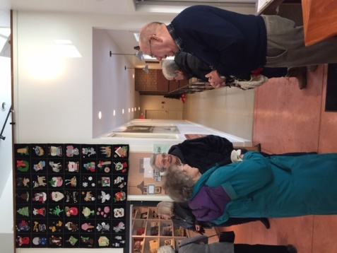

Picture: Residents Nancy Robbins and Mary Jane Henderson at the Skaneateles Historical Society Museum at the Creamery

**University of Rochester Course:**

**Contemporary Chinese Popular Culture**

**Tuesday December 19th –January 2nd 2:00pm-3:00pm**

This Series of Lectures will focus on exploring popular culture’s relations to social change, Chinese traditional values, Chinese school of thoughts, national identity, and globalization. The course includes topics in Chinese current media such as dynastic dramas, contemporary documentaries, and Chinese web-based novels.

Ting Huang, PhD Senior Lecturer in Chinese Language at the University of Rochester. Ting has taught Chinese language courses at all levels in college for 13 years including eight years of full-time teaching. She has also taught college-level Chinese language and writing coursesto native Chinese speakers, and graduate methods for teachers, K-12 language courses, and other language classes in the US and China, most of which were taught independently. Chinese is Ting’s Native language; she speaks standard Mandarin, native Wu dialect and has advanced skills in classical and modern Chinese.

**“UR” In Tune Lecture Series**

**Drumming Through the Ages**

**Thursday January 18th 4:00pm**

Drumming Through the Ages is a walk through the history of the drum from 1066 until the present. It will include how the drum is tuned, how it is played, how it was used throughout history, and how it is used along with other percussion instruments in the symphony orchestra. Concluding the presentation will be audience participation as each audience member will actually play a small percussion instrument along with me as soloist. You can call it the JAM SESSION. Guaranteed to be fun.

John H. Beck is Professor Emeritus of Percussion at the Eastman School of Music and retired Timpanist of the Rochester Philharmonic Orchestra. He is active throughout the United States, Europe and South America as a performer, composer, clinician and conductor. He is a past president of the Percussive Arts Society and has published numerous articles in professional journals. He is the editor of Encyclopedia of Percussion published by Routledge and has written many solos, percussion ensembles and instruction books for percussion. The proceeds from his book, Percussion Matters, Life at the Eastman School of Music go to the John Beck Percussion Scholarship Fund. He was inducted into the Percussive Arts Society Hall of Fame in 1999. On May 12, 2016 he received an honorary Doctor of Music degree from the College of Performing Arts, Rowan University, NJ.