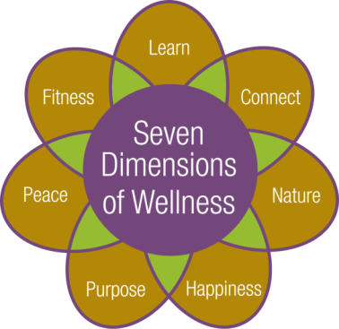



Cultural and Educational Program Calendar

**February 2018**





**Thursday, February 1st:**

9:00am – Water Fitness with Robin Gallagher. Pool

9:00am & 10:00am – Depart for shopping and banking

10:30am-12:00pm – Circuit Training. Exercise Room

11:00am – Fitness Video. Fitness Room

**\*11:30am –Depart for the Eastman at Washington Square Concert: *Goldberg for Three (I)* Presenting Bach’s Goldberg Variations. No fee to attend, brown bag lunches are welcome. Return approx. 1:30pm**

1:00pm – Gentle Yoga with Eva Kane. Fitness Room

2:00pm – Blood Pressure Screenings. Club Room

**\*4:00pm – “UR” In Tune lecture titled: *The Harvard Business School Comes to the Eastman School of Music* withMichael Alan Anderson, Associate Professor of Musicology, Eastman School of Music. Please see page 14 for course information. Community Center**



**Friday, February 2nd: Groundhog Day**

9:00am – Fitness Class with Robin Gallagher. Hahnemann Club

10:15am – Fitness Class with Robin Gallagher. Fitness Room

11:15am – Tech Time with facilitator Crystal Rothfuss, IT Technician. Share ideas, information and questions about technology. Topic: *Service Providers:* Spectrum, Frontier, other options (let’s compare)*.* Music Room

12:30pm – Aquatic Exercise Class with Students from Nazareth College. Pool

1:00pm – Catholic Mass with volunteers from St. Louis Church. Community Center

1:00pm – Pause for Peace Interfaith Worship Service with Chaplain Jim Grobe. Music Room

1:30pm-2:15pm – Open swim with Robin Gallagher. Pool

**2:30pm** – **Music Mixer, live entertainment duo with Top Brass. Community Center**

**7:15pm – Depart for the POPs Concert*: Broadway's Ashley Brown.* Please note ticket and transportation arrangements were made in advance. Return approx. 10:30pm**



**Saturday, February 3rd:**

10:30am – Tai Chi Class. Fitness Room

**\*11:00am – Pathway to Pittsford Errand Bus departs to Pittsford Plaza and Pittsford Library. The bus departs from the Highlands at 11:00am, 12:00pm and 1:00pm**

2:30pm – Saturday Musical: *Man of La Mancha (1972)* starring Peter O'Toole, Sophia Loren and James Coco. Music Room

**Sunday, February 4th:**

10:30am – Communion Service with volunteers from St. Louis Church. Laurelwood Activity Room

2:30pm – Movie: *Victoria and Abdul (2017)* starringJudi Dench, Ali Fazal, Eddie Izzard and Adeel Akhtar. Music Room

**6:00pm – Super Bowl LII Happy Hour. Kickoff on NBC television network (Channel 10). Enjoy tailgating food and the game with your neighbors. Snacks served from 6:00pm-7:30pm. Happy Hour pricing for beer and wine available from 6:00pm-7:00pm. Community Center**

**Monday, February 5th:**

9:00am – Fitness Class with Robin Gallagher. Hahnemann Club

**\*10:00am – Monthly Kitchen Tour: Tour is approx. 30 minutes long. Space is limited; please sign up in the Program Book. Meet outside Lilac Shop**

10:15am – Fitness Class with Robin Gallagher. Fitness Room

1:00pm – Euchre Group. Social Room

1:00pm-2:00pm – Open Swim with Robin Gallagher. Pool

**2:00pm – University of Rochester Course: *War, Innovation, and the Future* with Major Richard Sala, Marine Officer Instructor. Discuss the definition of war, the role of innovation and technology in war, and the effects of innovation over time. Please see page 15 for course description. Community Center**

**7:00pm – Monday Night Movie: *Learning to Drive (2015)* starring Patricia Clarkson, Ben Kingsley and Jake Weber. Community Center**

**Tuesday, February 6th:**

9:00am – Water Fitness with Robin Gallagher. Pool

9:00am & 10:00am – Depart for shopping and banking

10:30am-12:00pm – Circuit Training. Exercise Room

10:30am – Functional Fitness with Maureen Keller. Fitness Room

11:00am – Fitness Video. Fitness Room

1:15pm – Bible Study with Chaplain Jim Grobe. Laurelwood Gallery

**2:00pm – University of Rochester Lecture: *Campanology Romp Through the Ages* *(Bells Across Time)* with Doris Aman, carillonneur and Adjunct Instructor at River Campus Music Department. Learn about the history of bells and the background of the Hopeman Carillon at the University of Rochester. The University’s Carillon, Eijsbouts bells of Asten, Netherlands, was a gift from Dutch immigrants to memorialize the Hopeman family's patriarchal** **heritage**. **Community Center**

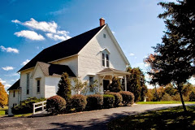

**Wednesday, February 7th:**

9:00am – Fitness Class with Robin Gallagher. Hahnemann Club

10:15am – Fitness Class with Robin Gallagher. Fitness Room

1:00pm-2:00pm – Open Swim with Robin Gallagher. Pool

**\*1:00pm – Depart for a tour of the Farmington Quaker Meeting House with Pastor Trish Eckert. Come explore a community that celebrates diversity. Quakers do not have a creed or a doctrine, so there are many beliefs, backgrounds and experiences represented. Walking is required. No fee to attend. Return approx. 4:00pm**

2:00pm – Fine Dining Food Forum. Seneca Dining Room

2:00pm – Pittsford Highlands Chorus practice. All are welcome to participate. Music Room

**4:30pm-6:00pm – Happy Hour: Drink specials and appetizers, Highlands’ Pub. This month’s featured Artist is Gil Jordan. In February we will display Gil’s watercolor paintings. Please join us as we share his collection with you.**

**Thursday, February 8th:**

9:00am – Water Fitness with Robin Gallagher. Pool

9:00am & 10:00am – Depart for shopping and banking

10:30am – Functional Fitness with Maureen Keller. Fitness Room

10:30am-12:00pm – Circuit Training. Exercise Room

11:00am – Fitness Video. Fitness Room

**\*11:30am –Depart for the Eastman at Washington Square Concert: *Goldberg for Three(II)* Presenting Bach’s Goldberg Variations. 2 Part Series finalizing the fifteen variations and**

**re-statement of the theme that occurs at the end of the work. No fee to attend, brown bag lunches are welcome. Return approx. 1:30pm**

**2:00pm – Presentation: *Opera Intro* with Joan Lehman, opera enthusiast. Enjoy a brief**

**introduction and overview of opera, followed by a showing and discussion of the opera,**

***Amahl and the Night Visitors*. Community Center**

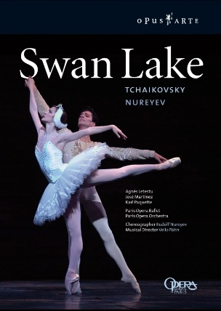**6:30pm – Depart for a Rochester Philharmonic Orchestra Concert: *Tchaikovsky’s Swan Lake*. Please note ticket and transportation arrangements were made in advance. Return approx. 10:00pm**

**Friday, February 9th**

9:00am – Fitness Class with Robin Gallagher. Hahnemann Club

10:15am – Fitness Class with Robin Gallagher. Fitness Room

12:30pm – Aquatic Exercise Class with Students from Nazareth College. Pool

1:15pm – Inspirational Hymns with Chaplain Jim Grobe. Laurelwood Gallery

1:30pm-2:15pm – Open Swim with Robin Gallagher. Pool

**2:30pm – Music Mixer, live entertainment with Tom and Peg, featuring piano and guitar. Laurelwood Gallery**

3:30pm – Current Events Club. Are you interested in discussing current issues, expressing your opinions, and being exposed to the ideas of your fellow residents? Music Room



**Saturday, February 10th:**

10:30am – Tai Chi Class with Dr. Kathy Gill. Fitness Room

1:00pm – Casual Bridge Game. All are welcome to join. Social Room

2:30pm – Saturday Musical Matinee: *The Music Man (1962)* starring Robert Preston, Shirley Jones and Buddy Hackett. Community Center

**Sunday, February 11th:**

10:30am – Communion Service with volunteers from St. Louis Church. Laurelwood Activity Room

1:30pm – Casual Bridge Game. All are we lcome to join. Social Room

1:30pm – Afternoon Music: Cheryl Frank recital featuring piano, violin, and viola. Community Center

2:30pm – Movie: *Terms of Endearment (1983)* starring Shirley MacLaine, Debra Winger, Jack Nicholson and Danny DeVito. Community Center

**Monday, February 12th:**

9:00am – Fitness Class with Robin Gallagher. Hahnemann Club

10:15am – Fitness Class with Robin Gallagher. Fitness Room

1:00pm – Euchre Group. Social Room

1:00pm-2:00pm – Open swim with Robin Gallagher. Pool

**2:00pm – University of Rochester Course: *War, Innovation, and the Future* with Major Richard Sala, Marine Officer Instructor. Discuss the definition of war, the role of innovation and technology in war, and the effects of innovation over time. Please see page 15 for course description. Community Center**

**2:30pm – Presentation: *Failure is Impossible*: *The story of Susan B. Anthony* with Jeanne Gehret. Laurelwood Activities Room**

**6:45pm – Depart for the Penfield Symphony Concert: *European Tour.* Please note ticket and transportation arrangements were made in advance. Return approx. 9:30pm**

**7:00pm – Evening Music with Total Sound, featuring piano. Community Center**

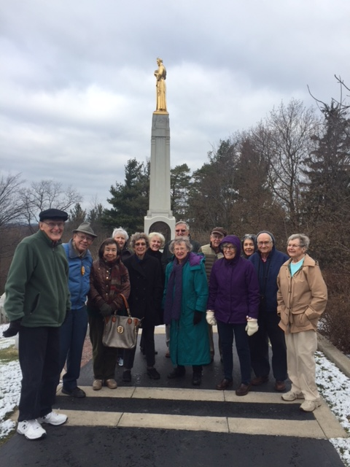

Residents visiting the Hill

Cumorah’s Visitor Center.

**Tuesday, February 13th: Mardi Gras**

9:00am – Water Fitness with Robin Gallagher. Pool

9:00am & 10:00am – Depart for shopping and banking

10:30am-12:00pm – Circuit Training. Exercise Room

10:30am – Functional Fitness with Maureen Keller. Fitness Room

11:00am – Fitness Video. Fitness Room

1:00pm – Knitting Group. Please bring your own supplies; yarn is available for charity knitting. Music Room

1:15pm – Bible Study with Chaplain Jim Grobe. Laurelwood Gallery

**2:00pm – Presentation: *Skyscraper* with researcher Donald Hall. Learn about the history and**

**recent building boom of very tall buildings. While two major inventions of the 19th**

**century enabled the building of the first skyscraper, 80% of the world's 100 tallest**

**buildings have been built since the year 2000. Don will explain and describe the tallest**

**buildings in the US and world today. Community Center**

**5:00pm-6:30pm – Fat Tuesday Mard i Gras Celebration dinner. Reservations are required for parties 5 or more. Dining Room**



**Wednesday, February 14th: Valentine’s Day / Ash Wednesday**

9:00am – Fitness Class with Robin Gallagher. Hahnemann Club

10:15am – Fitness Class with Robin Gallagher. Fitness Room

**\*12:45pm – Tour the Moonlight Creamery in Fairport, NY. Enjoy the smells and sweet tastes that Moonlight will offer. No Fee for the tour. For those who wish to partake, enjoy a blind taste test. Also make your own sundae, cost is $8.00. Walking is required. Return approx. 2:30pm**

1:00pm – Alzheimer’s Support Group for caregivers facilitated by Alzheimer’s Association staff and volunteers. The group provides updated information, emotional support, and problem solving as related to the challenges of giving care to those living with Alzheimer’s disease or other dementia. Seneca Dining Room

1:00pm-2:00pm – Open swim with Robin Gallagher. Pool

**1:15pm – Ash Wednesday Worship Service with Chaplain Jim Grobe. Laurelwood Gallery**

2:00pm – Pittsford Highlands Chorus practice. All are welcome to participate. Music Room

4:00pm-6:30pm – Valentine’s Day Happy Hour: Live music from Frank Herkimer on piano along with drink specials and appetizers. The Highlands’ Pub

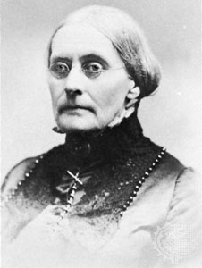**Thursday, February 15th: Susan B. Anthony’s Birthday**

9:00am – Water Fitness with Robin Gallagher. Pool

9:00am & 10:00am – Depart for shopping and banking

*10:00am-1:00pm –Parkinson Café: *Tips from the Experts on Home Safety and Balance*. A program designed to provide social, cultural, and intellectual interaction for people with Parkinson’s disease and their care partners.  A light lunch will be provided at no cost.  A donation of at least $2 per person is requested, as this is being provided by both The Highlands and National Parkinson’s Foundation.  Located at the Hahnemann Club, please request transportation.

10:30am – Functional Fitness with Maureen Keller. Fitness Room

10:30am-12:00pm – Circuit Training. Exercise Room

**\*10:30am- 12:00pm – 2 PART Colored Pencil Art Class with instructor Elaine Rittler. Step-by-step guided instruction. No prior art or drawing skills required. The colored pencil project will be accomplished over two sessions, join us for BOTH exciting, fun and relaxing classes! All materials are provided, no fee to attend. 2nd floor Activities Room**

11:00am – Fitness Video. Fitness Room

11:00am – Pray the Rosary with volunteers from St. Louis Church. Music Room

1:00pm – Gentle Yoga with Eva Kane. Fitness Room

2:00pm – Blood Pressure Screenings. Club Room

**2:00pm – Documentary Film: *Susan B. Anthony: Rebel for the Cause.* Interviews with historians, illustrations, photographs and dramatizations document the life and legacy of suffragist Susan B. Anthony in this A&E biography. Community Center**



**Friday, February 16th:**

9:00am – Fitness Class with Robin Gallagher. Hahnemann Club

10:15am – Fitness Class with Robin Gallagher. Fitness Room

11:15am – Tech Time with facilitator Crystal Rothfuss, IT Technician. Share ideas, information and questions about technology. Topic: *Consumer Electronics* (a little bit of electronics in everything).Music Room

12:30pm – Aquatic Exercise Class with Students from Nazareth College. Pool

1:15pm – Inspirational Hymns with Chaplain Jim Grobe. Laurelwood Gallery

1:30pm-2:15pm – Open Swim with Robin Gallagher. Pool

**2:30pm** – **Music Mixer, live entertainment with Brad Batz Jazz Duo. Community Center**

**Saturday, February 17th:**

**9:00am-11:00am – Saturday Breakfast Guest Day, Valentine’s Day Celebration. Dining Room**

10:30am – Tai Chi Class with Dr. Kathy Gill. Fitness Room

**\*11:00am – Pathway to Pittsford Errand Bus departs to Pittsford Plaza and Pittsford Library. The bus departs from the Highlands at 11:00am, 12:00pm and 1:00pm.**

**1:30pm – Afternoon Music: Fiddler of the Genesee. Community Center**

2:30pm – Saturday Musical Matinee: *Best in Show (2000)* starring Christopher Guest, Eugene Levy and Catherine O'Hara. Music Room

**Sunday, February 18th:**

10:30am – Communion Service with volunteers from St. Louis Church. Laurelwood Activity Room

11:00am – Trivia: Presidents. Laurelwood Hearth Room

2:30pm – Movie: *Quiet American (2002*) starring Michael Caine, Brendan Fraser, and Do Thi Hai Yen. Community Center



**Monday, February 19th: President’s Day**

9:00am – Fitness Class with Robin Gallagher. Hahnemann Club

10:15am – Fitness Class with Robin Gallagher. Fitness Room

1:00pm – Euchre Group. Social Room

1:00pm-2:00pm – Open swim with Robin Gallagher. Pool

**2:00pm – University of Rochester Course: 3 Part Series: *War, Innovation, and the Future* with Major Richard Sala, Marine Officer Instructor. Discuss the definition of war, the role of innovation and technology in war, and the effects of innovation over time. Please see page 15 for course description. Music Room**

**3:00pm-4:00pm – iPhone/iPad Class with Crystal Rothfuss, IT Technician. Session will offer instruction on general maintenance and cleanup, with an open forum to follow. Please bring your devices with you. Music Room**

**\*7:00pm – Depart for Flower City Jazz Society Concert ­­­: *Smug Town Stompers* with vocalist Carol Mulligan. Tickets are $12.00 each, pay upon arrival. Return approximately 10:00pm.**



**Tuesday, February 20th:**

9:00am – Water Fitness with Robin Gallagher. Pool

9:00am & 10:00am – Depart for shopping and banking

10:30am – Functional Fitness with Maureen Keller. Fitness Room

10:30am-12:00pm – Circuit Training. Exercise Room

11:00am – Fitness Video. Fitness Room

1:15pm – Bible Study with Chaplain Jim Grobe. Laurelwood Gallery

**1:30pm-3:00pm – The Highlands at Pittsford’s Winter Olympics! Be a part of Team Highlands! Games, fun, friendly competition and lots of laughs guaranteed! Show your support for Team USA & wear your red, white, and blue. Community Center**

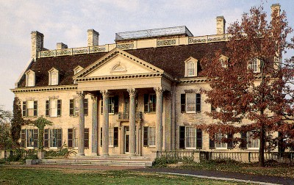

**Wednesday, February 21st:**

9:00am – Fitness Class with Robin Gallagher. Hahnemann Club

10:15am – Fitness Class with Robin Gallagher. Fitness Room

1:00pm-2:00pm – Open swim with Robin Gallagher. Pool

**\*1:00pm – Depart for a tour of the Historic George Eastman Mansion, along with experiencing the Mansions Dutch Connection Display. The Conservatory will feature thousands of tulips, hyacinths, daffodils, amaryllis, and freesias, in various vibrant shades—the same colors George Eastman featured 100 years ago. Admission fee is $11.00, and will be collected on the bus. Walking is required. Return approx. 4:00pm**

No Pittsford Highlands Chorus practice today

**2:00pm – Presentation: *Music and life of Kitty Kallen* with Larry Shearer. Laurelwood Activity Room**

4:30pm-6:00pm – Happy Hour: drink specials and appetizers. The Highlands’ Pub

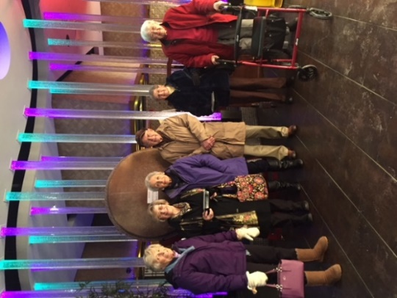

Residents Mary Kay Kidd, Norma Riedman, Gayle Ader, Al Lorenzo, Jeanne Carley and

Roberta Faloon enjoying lunch at Umi Japanese Steak House.

**Thursday, February 22nd:**

9:00am – Water Fitness with Robin Gallagher. Pool

9:00am & 10:00am – Depart for shopping and banking

10:30am – Functional Fitness with Maureen Keller. Fitness Room

10:30am-12:00pm – Circuit Training. Exercise Room

**\*10:30am- 12:00pm – 2 PART Colored Pencil Art Class with instructor Elaine Rittler. Step-by-step guided instruction. No prior art or drawing skills required. The colored pencil project will be accomplished over two sessions, join us for BOTH exciting, fun and relaxing classes! All materials are provided, no fee to attend. 2nd floor Activities** **Room**

**\*2:00pm – Hands-On-Baking Class: Featuring chocolate dipped strawberries along with dipping other sweet and salty snacks, with Pastry Chef Laura Gilbert. Community Center**



**Friday, February 23rd:**

No fitness classes today with Robing Gallagher.

10:15am – Fitness video. Fitness Room

1:15pm – Worship Service with Chaplain Jim Grobe. Laurelwood Gallery

12:30pm – Aquatic Exercise Class with Students from Nazareth College. Pool

No open Swim today with Robin Gallagher.

**2:30pm** – **Music Mixer, live entertainment with Dick Stacy Rhythm Aces Duo. Laurelwood Gallery**

3:30pm – Current Events Club. Are you interested in discussing current issues, expressing your opinions, and being exposed to the ideas of your fellow residents? Music Room

**7:15pm – Depart for a POPS concert: *Latin Heat with the Mambo Kings*. Please note ticket and transportation arrangements were made in advance. Return approx. 10:30pm**



**Saturday, February 24th:**

10:30am – Tai Chi Class with Dr. Kathy Gill. Fitness Room

1:30pm – Game: Scrabble. Laurelwood Activity Room

2:30pm – Saturday Musical Matinee: *RENT (2005)* starring Anthony Rapp, Adam Pascal and Rosario Dawson. Community Center

**Sunday, February 25th:**

10:30am – Communion Service with volunteers from St. Louis Church. Laurelwood Activity Room

1:30pm – Casual Bridge Game. All are welcome to join. Social Room

2:30pm – Movie: *Billy Elliot (2000)* starring Jamie Bell, Jean Heywood and Jamie Draven

****Community Center

**Monday, February 26th:**

9:00am – Fitness Class with Robin Gallagher. Hahnemann Club

10:15am – Fitness Class with Robin Gallagher. Fitness Room

11:15am – Cultural Programming Meeting. All are welcome to join to discuss programming suggestions. Music Room

**\*12:00pm – Winter Picnic. No fee to attend. Dining Room**

1:00pm – Euchre Group. Social Room

1:00pm-2:00pm – Open swim with Robin Gallagher. Pool

**2:00pm – Monthly Resident Meeting. Community Center**



**Tuesday February 27th:**

9:00am – Water Fitness with Robin Gallagher. Pool

9:00am & 10:00am – Depart for shopping and banking

10:30am – Functional Fitness with Maureen Keller. Fitness Room

10:30am-12:00pm – Circuit Training. Exercise Room

11:00am – Fitness Video. Fitness Room

1:00pm – Walking Club. Meet in the Wellness Center

**1:00pm-3:00pm Wellness Fair: Vendors will include home care agencies, pharmacies, and wellness specialties. Community Center**

1:15pm – Bible Study with Chaplain Jim Grobe. Laurelwood Gallery

2:00pm – Prayer Service with Chaplain Jim Grobe. Music Room

**6:30pm – Evening Music with Mike Burrell on vocals. Laurelwood Gallery**



**Wednesday, February 28th: Purim begins at Sundown.**

9:00am – Fitness Class with Robin Gallagher. Hahnemann Club

10:15am – Fitness Class with Robin Gallagher. Fitness Room

**\*11:30am – Depart for lunch at The Cheesecake Factory. Enjoy soups, salads, pizza, pasta, and of course cheese cake. Return approx. 2:00pm**

1:00pm-2:00pm – Open Swim with Robin Gallagher. Pool

2:00pm – Pittsford Highlands Chorus practice. All are welcome to participate. Music Room

4:30pm-6:00pm –Happy Hour: drink specials and appetizers. Highlands’ Pub

The Pittsford Highlands’ Chaplain, Jim Grobe, is available for one on one meetings. If interested, please contact Elizabeth David ext. 6344 and a date and time can be arranged.

**“UR” In Tune Lecture:**

**The Harvard Business School Comes to the Eastman School of Music**

**Thursday, February 1st at 4:00pm**

The case study method is a teaching tool that has served business administration programs for more than a century. This approach highlights real business problems that develop students’ analytical and decision-making abilities. The Harvard Business School has a virtual monopoly on the market of case studies, but those that specifically target music institutions are few and far between. The Eastman Case Study Series is the first of its kind to apply the case method exclusively to business problems faced by musical arts organizations. Professor Michael Anderson outlines the value and method of case study teaching and provides a glimpse of the wide range of fascinating music institutions that have been profiled in the Eastman Case Study Series.

**Speaker Biography**

Michael Alan Andersonspecializes in a wide range of issues related to sacred music from the fourteenth through the sixteenth century, with emphasis on the saints and lay devotion. He is the author of the book [*St. Anne in Renaissance Music: Devotion and Politics*](http://www.cambridge.org/us/academic/subjects/music/medieval-and-renaissance-music/st-anne-renaissance-music-devotion-and-politics)(Cambridge University Press, 2014). Anderson is a two-time winner of ASCAP’s Deems Taylor Award for outstanding writing about music, for articles published in 2011 and in 2013. He is also the 2012 winner of the Noah Greenberg Award, given by the American Musicological Society for outstanding contributions to historical performance practices. In 2013, he received the University of Rochester’s Provost Multidisciplinary Award, which involved producing first recordings of medieval music supplied to the newly-installed medieval gallery at the Memorial Art Gallery.

As managing editor of *The Eastman Case Studies* series through the school’s Institute for Music Leadership, he oversees the publication of essays examining business administration issues in musical arts organizations across the country.

Still an active performer, Anderson has served as Artistic Director of Schola Antiqua since 2008, following the retirement of medievalist Calvin M. Bower, with whom he co-founded the organization in 2000. Schola Antiqua is a Chicago-based professional vocal ensemble dedicated to the performance of music before 1600

As a choral conductor, Anderson has further served as the Assistant Director of the Rockefeller Memorial Chapel Choir, and as a guest conductor of the Notre Dame Glee Club. Meantime as a singer, he performed for three seasons with the Chicago Symphony Chorus, under the batons of Barenboim, Boulez, Penderecki, Mehta, Eschenbach, Rostropovich, and others in venues from Orchestra Hall and the Ravinia Festival in Chicago to Carnegie Hall and the Berlin Philharmonie.

**University of Rochester Course Offering:**

**War, Innovation and the Future**

**Monday, February 5th – 19th at 2:00pm**

Discuss the definition of war, the role of innovation and technology in war, and the effects of innovation over time.

**Speaker Biography**

Major Sala serves as the Marine Officer Instructor and Assistant Professor of Naval Science, Naval Reserve Officers Training Corps (NROTC), Rochester. NROTC Rochester includes: The University of Rochester, Rochester Institute of Technology, the College at Brockport (State University of New York), and St. John Fisher College.

Major Sala is a native of Queens, New York. He received his commission, as an Officer in the United States Marine Corps, through the NROTC program at the University of Colorado, Boulder.

After completing his deployment with Marine Rotational Force-Darwin, Captain Sala joined the Office of the Staff Judge Advocate, 1st Marine Division, and served as the Assistant Deputy Staff Judge Advocate.

Captain Sala reported for duty as Marine Officer Instructor, Naval Reserve Officers Training Corps (NROTC), Rochester, in June 2016. He was promoted to Major in July 2017. In the summer of 2017, Major Sala served as the Academics Office-in-Charge, Officer Candidates School, Quantico, Virginia.

Major Sala’s decorations include the Navy and Marine Corps Commendation Medal and the Navy and Marine Corps Achievement Medal with gold star in lieu of second award. He is the recipient of the 2-08 Major General Edwin B. Wheeler Award for infantry excellence and the Lieutenant Colonel Vic Taylor Award for being the Distinguished Graduate at the Infantry Officer Course at The Basic School.

He married Mrs. Melanie A. Sala (McGrath) in December 2001. Richard and Melanie have two children, Lidia and Taggart.