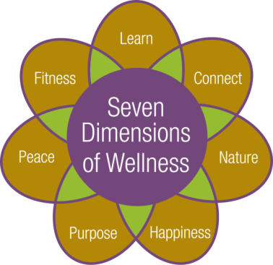



**Cultural and Educational Program Calendar**

so00941_so00941_**December 2017**

****

**C:\Documents and Settings\memcdonald\Local Settings\Temporary Internet Files\Content.IE5\FWATF1WO\MC900323014[1].wmf**



**Friday, December 1st:**

9:00am – Fitness Class with Robin Gallagher. Hahnemann Club

10:15am – Fitness Class with Robin Gallagher. Fitness Room

**11:15am – Tech Time with facilitator Crystal Rothfuss. Share ideas, information and questions about technology. Topic will be regarding privacy. Music Room**

1:00pm-2:00pm – Open swim with Robin Gallagher. Pool

**1:00pm – Catholic Mass with volunteers from St. Louis Church. Community Center**

**1:00pm – Pause for Peace Interfaith Worship Service with Chaplain Jim Grobe. Music Room**

**2:30pm – Music Mixer, live entertainment with Brad Batz Jazz Duo. Community Center**

**Saturday, December 2nd:**

**\*9:30am – Depart for the Crafts for a Cause Holiday Craft Show at the Eastside Family YMCA. The fair has approx. 90+ vendors and vendor’s booth fees benefit the YMCA’s annual campaign. No Admission Fee. Return approx. 12:30pm**

10:30am – Tai Chi Class with Dr. Kathy Gill. Fitness Room

2:30pm – Musical Saturday Movie Matinee: Seven Brides for Seven Brothers (1954) staring Howard Keel and Jeff Richards. Music Room

**Sunday, December 3rd:**

10:30am – Communion Service with volunteers from St. Louis Church. Laurelwood Activity Room

11:00am – Trivia: What do you know? Laurelwood Hearth Room

2:30pm – Movie: Burzynski (2010) Documentary staring Joe Barton and Stanislaw Burzynski. Community Center

**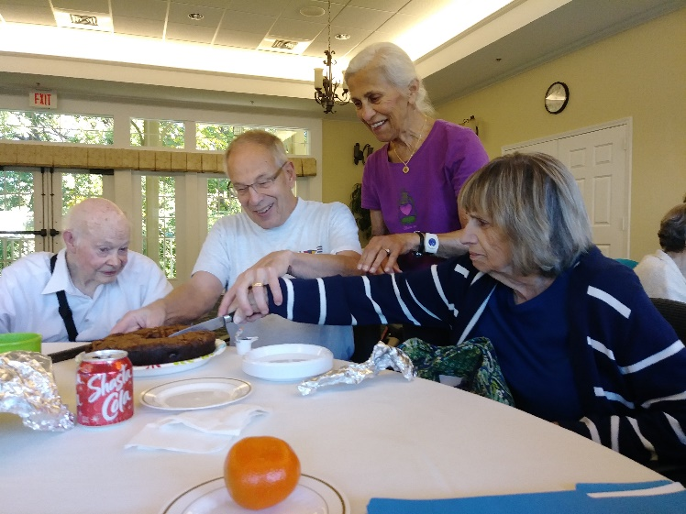**



Birthday Celebration for Van VanZanten and Alice VanDusen

**Monday, December 4th:**

9:00am – Fitness Class with Robin Gallagher. Hahnemann Club

**\*10:00am – Monthly Kitchen Tour. Tour is approx. 30 minutes long. Space is limited; please sign up in the Program Book. Meet outside Lilac Shop**

10:15am – Fitness Class with Robin Gallagher. Fitness Room

1:00pm – Euchre Group. Social Room

1:00pm-2:00pm – Open swim with Robin Gallagher. Pool

1:15pm – Inspirational Hymns with Chaplain Jim Grobe. Laurelwood Gallery

**2:00pm – University of Rochester Lecture: *Animal Cracks* with Melissa Belmain, instructor, journalist, and editor. When you need a laugh, it's hard to beat poems about animals. Melissa will share a zooful of humorous verse by poets past and present. Community Center.**

**6:45pm – Depart for the Penfield Symphony Concert: *Music to Warm Your Heart.* Please note tickets and transportation arrangements were made in advance. Return approx. 9:30pm**

**7:00pm – Evening music with Rochester Rhapsody. Community Center**



**Tuesday, December 5th:**

9:00am – Water Fitness with Robin Gallagher. Pool

9:00am & 10:00am – Depart for shopping and banking

10:30am-12:00pm – Circuit Training. Exercise Room

11:00am – Fitness Video. Fitness Room

1:15pm – Bible Study with Chaplain Jim Grobe. Laurelwood Gallery

**2:00pm – University of Rochester Course: *William Faulkner:* *His Life, Times, and Writings: The Years at the University of Virginia* with Rufino Pabico, MD. Please see page 15 for course information. Community Center**

**\*4:00pm – To Your Health Lecture: *New Treatment for Chronic Hip & Knee Pain*, with Dr. Joel Kent. The lecture is located at the Hahnemann Club.  Transportation provided at 3:45pm. Return approx. 5:30pm.**

**\*4:45pm – Depart for The Town of Pittsford’s Candlelight Night. An annual holiday celebration**

**featuring live music, carolers, and visits with Santa. Explore the village of Pittsford and**

**shop! Walking is required. Two possible return departure times: 6:30pm and 8:00pm.**

**7:00pm – Game Night! Games are provided or bring your favorite game to share! Music Room**

**Wednesday, December 6th:**

9:00am – Fitness Class with Robin Gallagher. Hahnemann Club

10:15am – Fitness Class with Robin Gallagher. Exercise Room

\*12:00pm – Depart for The Pittsford Highlands chorus performance at the Pittsford Senior Center. **Transportation will be provided for singers only**. Return approx. 2:00pm

1:00pm-2:00pm – Open swim with Robin Gallagher. Pool

No Pittsford Highlands Chorus practice today

**3:30pm – Annual Resident and Employee Holiday Party including the presentation of the Employee Appreciation Fund checks in the Community Center, followed by a buffet style dinner at 4:30pm. Live entertainment by Henry Boessl on piano in the Music Room.**

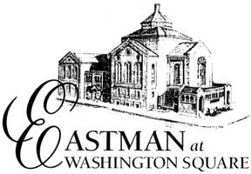**Thursday, December 7th:**

9:00am – Water Fitness with Robin Gallagher. Pool

9:00am & 10:00am – Depart for shopping and banking

10:30am-12:00pm – Circuit Training. Exercise Room

11:00am – Fitness Video. Fitness Room

**\*11:30am – Eastman at Washington Square Concert: *Mbira dzeMugomo Guru.* Music from the Shona spiritual traditions of Zimbabwe. No fee to attend, brown bag lunches are welcome. Return approx. 1:30pm**

1:00pm – Gentle Chair Yoga with Eva Kane. Fitness Room

2:00pm – Blood Pressure Screenings. Club Room

**\*2:00pm** – **Join us for decorating gingerbread houses. Show off your creativity! Finished gingerbread houses will be put on display in the common areas. Bistro**

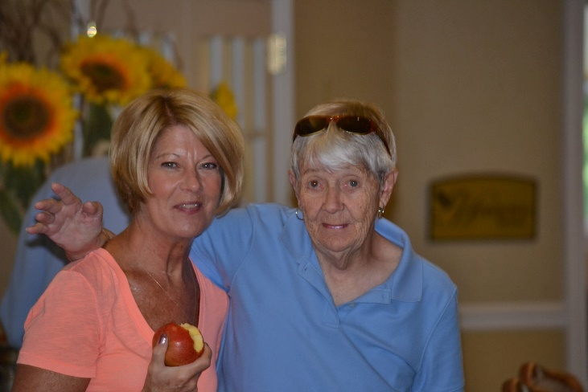

Judy Sims and Joan Volonte Enjoying the 2017 Harvest Festival

**Friday, December 8th:**

9:00am – Fitness Class with Robin Gallagher. Hahnemann Club

**\*9:00am – Depart for a trip to the Hill Cumorah Visiting Center to explore nativities from around the world. There are roughly 80 different nativity scenes representing about 40 different countries that were donated by area residents and collectors. No feel to attend. Return Approx. 12:00pm**

10:15am – Fitness Video. Fitness Room

**11:00am – Christmas Caroling with Nazareth College Music Therapy Club. Laurelwood Gallery.**

1:00pm-2:00pm – Open swim with Robin Gallagher. Pool

No Inspirational Hymns with Chaplin Jim Grobe today

**2:30pm – Music Mixer with New Horizons Big Band. Community Center**

**3:30pm – Current Events Club. Discuss current issues of the day, express your opinions, and be exposed to the ideas of your fellow residents. Music Room**

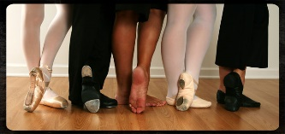

**Saturday, December 9th:**

10:30am – Tai Chi Class with Dr. Kathy Gill. Fitness Room

\*11:00am – Pathway to Pittsford Errand Bus departs to Pittsford Plaza, Pittsford Cinema and Pittsford Community Library. The bus departs from the Highlands at 11:00am, 12:00pm and 1:00pm.

**2:30pm – Dance Recital with children ages 10-17yrs old from the East Rochester Dance Studio. Community Center**

2:30pm – Musical Saturday Movie Matinee: *The Fantasticks* staring Joel Grey and Nernard Hughes. **Wellness Center**

**Sunday, December 10th:**

10:30am – Communion Service with volunteers from St. Louis Church. Laurelwood. Activity Room

1:30pm – Casual Bridge Game. All are welcome to join. Social Room

**1:30pm – Afternoon Music: Kate Bohanas Piano Studio winter recital, piano performances by students of all ages. Community Center**

2:30pm – Movie: Annie Hall, staring Woody Allen and Diane Keaton. Music Room

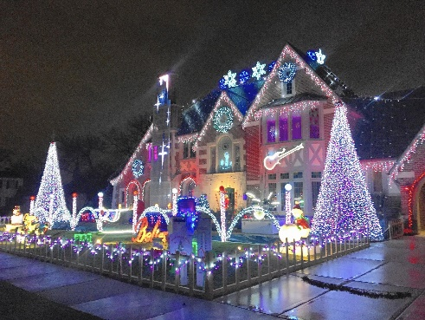**Monday, December 11th:**

9:00am – Fitness Class with Robin Gallagher. Hahnemann Club

10:15am – Fitness Class with Robin Gallagher. Fitness Room

**11:15am – Cultural Programming Meeting. Music Room**

1:00pm – Euchre Group. Social Room

1:00pm-2:00pm – Open swim with Robin Gallagher. Pool

1:15pm – Bible Study with Chaplain Jim Grobe. Laurelwood Gallery

**2:00pm – Monthly Resident Meeting. Community Center**

**3:00pm**-**5:00pm – The Alzheimer's Association Presents, A Video Education Series: *Effective Communication and Understanding Behaviors* with Elizabeth Marsh, MT-BC. This interactive video education series will provide information on various topics as they relate to Alzheimer’s disease and other dementia. The sessions are intended to connect care partners with experts such as physicians, researchers, and attorneys. Music Room**

**3:15pm – Winter Social: Come enjoy each other’s company around the fire place with a cup of hot chocolate and trivia. Living Room**

**\*6:15pm – Depart for a Christmas Lights Evening Ride (Group 1) to see festive outdoor holiday decorations. Please sign up in the program book for Group 1. Return at approx. 7:15pm**

**\*7:45pm – Depart for a Christmas Lights Evening Ride (Group 2) to see festive outdoor holiday decorations. Please sign up in the program book for Group 2. Return at Approx. 8:45pm**

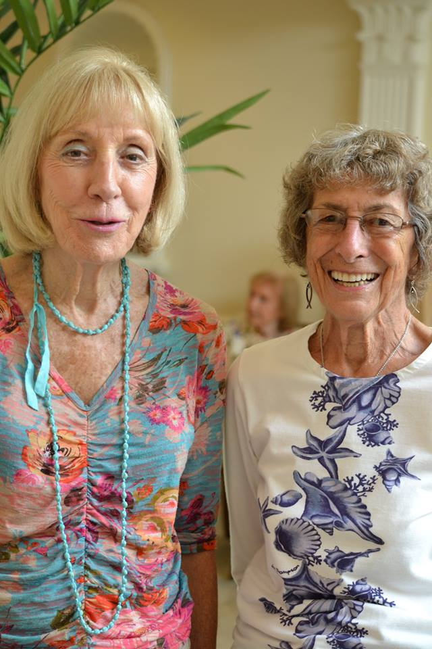

Resident Suzanne Eichhorn with Nancy Hare at the Harvest Festival.

**Tuesday, December 12th: Hanukkah begin at sunset**

9:00am – Water Fitness with Robin Gallagher. Pool

9:00am & 10:00am – Depart for shopping and banking

10:30am-12:00pm – Circuit Training. Exercise Room

11:00am – Fitness Video. Fitness Room

1:00pm – Knitting Group. Bring your own supplies; yarn is available for charity knitting. Music Room

No Bible study with Chaplin Jim Grobe today

**\*2:00pm** –**Depart for Christmas Caroling at the Highlands Living Center to spread some goodwill and holiday cheer to our friends on campus with guitarist Karen LaBella leading the way. Music lyrics will be provided. Return at approx. 3:15pm**

**2:30pm – Travelogue presentation: *An English Christmas* with Christine Simons. Laurelwood Activity Room**

**\*4:00pm – To Your Health Lecture: *Proper Foot Care for Seniors*, with Dr. Pearce Sloan. The lecture is located at the Hahnemann Club.  Transportation provided at 3:45pm. Return approx. 5:30pm.**

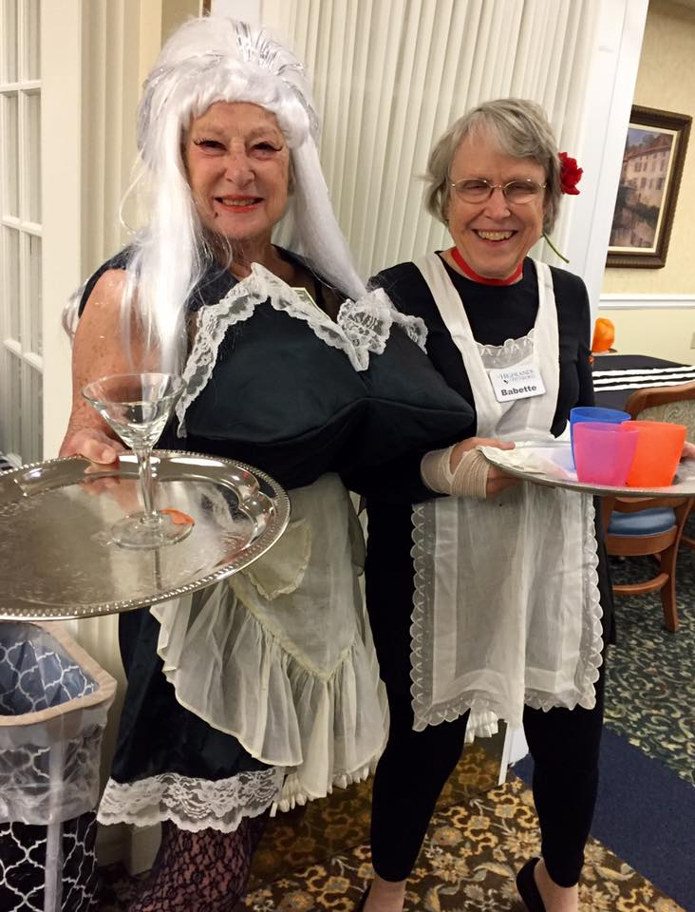

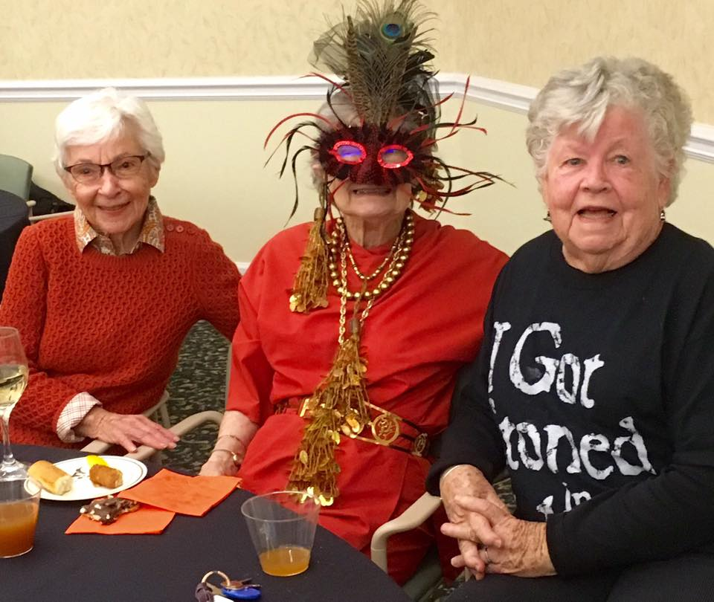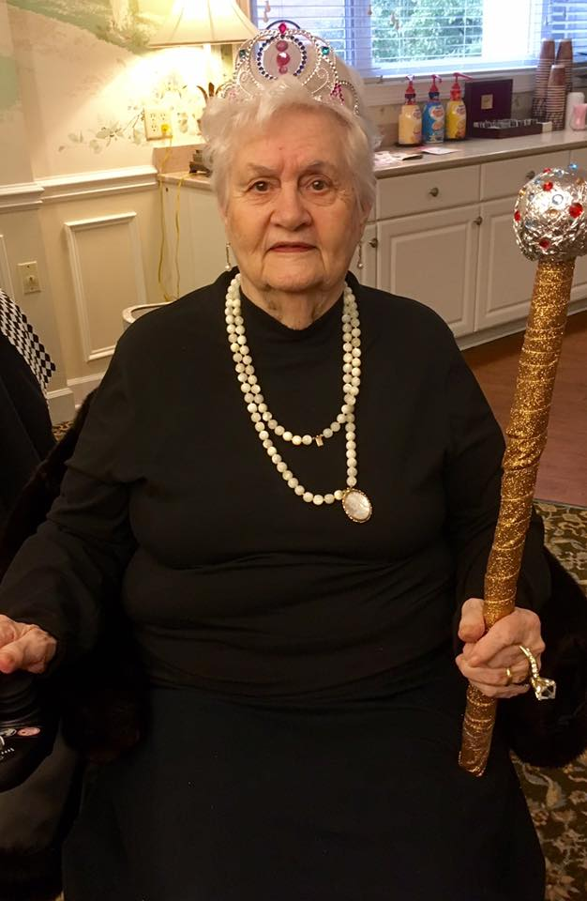

Halloween Party: Residents Nancy Robbins, Betty Iwan, Verna Doeltz, Joanne Hirsch, Pope Jamesson and Ginny Peterssen in Costume

**Wednesday, December 13th:**

9:00am – Fitness Class with Robin Gallagher. Hahnemann Club

10:15am – Fitness Class with Robin Gallagher. Fitness Room

1:00pm-2:00pm – Open swim with Robin Gallagher. Pool

**1:00pm – Alzheimer’s Support Group for caregivers facilitated by Alzheimer’s Association staff and volunteers. The group provides updated information, emotional support, and problem solving as related to the challenges of giving care to those living with Alzheimer’s disease or other dementia. Seneca Dining Room**

**\*1:15pm – Depart for the George Eastman House for the 21st Annual Sweet Creations Exhibition. The**

**display features clever confections from professional bakers, families, and community groups. Admission is $10.00 per person and will be collected on the bus. Return Approx. 4:30pm**

**2:00pm – Hanukkah celebration with musician Susan Krasner, vocals and keyboard. Laurelwood Gallery**

2:00pm – Fine Dining Food Forum. Community Center

2:00pm – Pittsford Highlands Chorus practice. Music Room

**4:30pm-6:00pm – Happy Hour: drink specials and appetizers. Highlands’ Pub. Our featured Artist this month is Helen Woodmansee. In December we will display Helen’s art work in the Art Gallery.**

**6:45pm – Evening Music with Geoff Cough on Keyboard. Laurelwood Gallery**

**Thursday, December 14th:**

9:00am – Water Fitness with Robin Gallagher. Pool

9:00am & 10:00am – Depart for shopping and banking

10:30am-12:00pm – Circuit Training. Exercise Room

11:00am – Fitness Video. Fitness Room

**2:00pm – University of Rochester Lecture: *Water management in the ancient world: From buckets to aqueducts* with Professor John Lambropoulos, PhD., Chair of the Department of Mechanical Engineering at The University of Rochester. Community Center**

**6:30pm – Depart for Rochester Philharmonic Orchestra Concert: *Vivaldi’s Four Season.***

**Please note transportation arrangements were made in advance. Return approx. 10:30pm**

**Friday, December 15th:**

9:00am – Fitness Class with Robin Gallagher. Hahnemann Club

10:15am – Fitness Class with Robin Gallagher. Fitness Room

**11:15am – Tech Time: with facilitator Crystal Rothfuss. Share ideas, information and questions about technology. Music Room**

**\*1:00pm – Shopping at Eastview Mall, Target and Victor Crossings Plaza. Store selection includes: Dollar Store, HomeGoods, Wal-Mart, Kohl’s, and PetSmart. Return approx. 4:00pm**

1:00pm-2:00pm – Open swim with Robin Gallagher. Pool

1:15pm – Worship Service with Chaplain Jim Grobe. Laurelwood Gallery

**2:30pm – Music Mixer, live entertainment with Ray Braselton on guitar featuring a Christmas program. Laurelwood Gallery**

**Saturday, December 16th:**

**9:00am-11:00am – Saturday Breakfast with Santa, Guest Day: Bring your family and enjoy this wonderful holiday gathering. Dining Room**

10:30am – Tai Chi Class Dr. Kathy Gill. Fitness Room

2:30pm – Musical Saturday Movie Matinee: Zoot Suit (1981), staring Edward James Olmos, Daniel Valdez. Music Room

**3:00pm – Christmas caroling with St. Louis Church Youth Group. Laurelwood Gallery**

**Sunday, December 17th:**

**\*9:00am – Depart for a Dickens Christmas in Skaneateles, including a tour of the Skaneateles Historical Society Museum at the Creamery. Enjoy lunch at the Blue Water Grill, menu includes salads, sandwiches, burgers and sushi. Finish up those last minute gifts while shopping in the village. No fee to attend. Walking is required. Returning approx. 4:30pm**

10:30am – Communion Service with volunteers from St. Louis Church. Laurelwood Activity Room

1:30pm – Afternoon Music with Boris and Alla featuring violin and piano. Laurelwood Gallery

2:30pm – Movie: Ring the Bell (2013) staring, Ryan Scharoun and Ashley Anderson McCarthy. Community Center

**Monday, December 18th:**

9:00am – Fitness Class with Robin Gallagher. Hahnemann Club

10:15am – Fitness Class with Robin Gallagher. Fitness Room

**11:00am – Hanukkah celebration and lighting of the Menorah with Rabbi Yitzi Hein. Light refreshments will be served. Music Room**

1:00pm-2:00pm – Open swim with Robin Gallagher. Pool

1:00pm – Euchre Group. Social Room

**2:00pm** **– Presentation: *Rochester Area Community Foundation* with Jennifer Leonard.The largest grant making foundation in Central and Western New York, has helped put poverty and racial inequities on the forefront of Rochester’s civic agenda. Supporting interests include arts, historical preservation and aging. Community Center**

**4:00pm – Getting through the holidays without loved ones with Chaplain Jim Grobe. Music Room**

**\*7:00pm – Depart for Flower City Jazz Society Concert with the Roger Eckers Little Big Band.** **Tickets are $12.00 each, pay upon arrival. Return approximately 10:00pm**

**7:00pm – Monday Night Movie: It’s a Wonderful Life (1946). Community Center**

**Tuesday, December 19th:**

9:00am – Water Fitness with Robin Gallagher. Pool

9:00am & 10:00am – Depart for shopping and banking

10:30am-12:00pm – Circuit Training. Exercise Room

11:00am – Fitness Video. Fitness Room

\*12:00pm – Depart for The Pittsford Highlands Chorus performance at the Pittsford Senior Center. **Transportation will be provided for singers only**. Return approx. 2:00pm

1:15pm – Christmas Stories with Chaplain Jim Grobe. Laurelwood Gallery

2:00pm – Christmas Prayer Service with Chaplin Jim Grobe. Music Room

No chorus practice today

**2:00pm – University of Rochester Course: *Contemporary Chinese Popular Culture* with Ting Huang PhD., Senior Lecturer in Chinese Language at the University of Rochester. Please see page 15 for course information. Community Center**

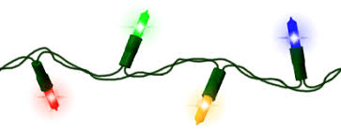**7:00pm – Game Night! Games are provided or bring your favorite game to share! Music Room**

**Wednesday, December 20th:**

9:00am – Fitness Class with Robin Gallagher. Hahnemann Club

10:15am – Fitness Class with Robin Gallagher. Fitness Room

1:00pm-2:00pm – Open swim with Robin Gallagher. Pool

**2:00pm – The Pittsford Highlands chorus performance: Christmas Around the World. Community Center**

2:00pm – Blood Pressure Screenings. Club Room

4:30pm-6:00pm – Happy Hour: drink specials and appetizers. Highlands’ Pub

**Thursday, December 21st: First Day of Winter**

9:00am – Water Fitness Class with Robin Gallagher. Pool

9:00am & 10:00am – Depart for shopping and banking

10:30am-12:00pm – Circuit Training. Exercise Room

11:00am – Fitness Video. Fitness Room

11:00am – Pray the Rosary with volunteers from St. Louis Church. Music Room

**\*1:00pm – Depart for the Lamberton Conservatory to view the beautiful Christmas display featuring poinsettias. Admission fee $1.00 collected on the bus. Returning Approx. 4:00pm**

1:00pm – Gentle Chair Yoga with Eva Kane. Fitness Room

**Friday, December 22nd:**

9:00am – Fitness Class with Robin Gallagher. Hahnemann Club

10:15am – Fitness Class with Robin Gallagher. Fitness Room

1:00pm-2:00pm – Open swim with Robin Gallagher. Pool

1:15pm – Christmas Worship Service with Chaplain Jim Grobe. Laurelwood Gallery

2:00pm – Blood Pressure Screenings. Club Room

**2:30pm – Music Mixer, live entertainment with Dick Leshhorn on keyboard. Community Center**

**7:15pm – Depart for the POPs Concert*: Gala Holiday Pops.*  Please note transportation arrangements were made in advance. Return approx. 10:30pm**

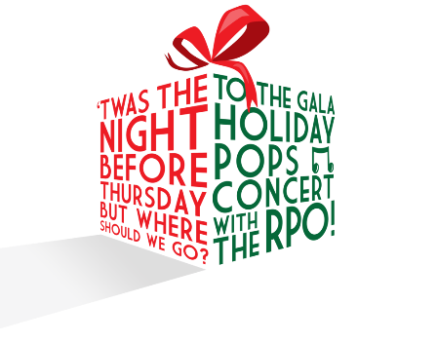

**Saturday, December 23rd:**

10:30am – Tai Chi Class Dr. Kathy Gill. Fitness Room

2:30pm – Musical Saturday, Movie Matinee: The Polar Express (2004) starring Tom Hanks. Music Room

**3:00pm – Afternoon Classical Music: *Music for Love*. Community Center**

**Sunday, December 24th: Christmas Eve**

10:30am – Communion Service with volunteers from St. Louis Church. Laurelwood Activity Room

1:30pm – Casual Bridge Game. All are welcome to join. Social Room

2:30pm – Movie: Christmas in Connecticut (1945) staring Barbara Stanwyck and Dennis Morgan. Community Center

**5:00pm- 6:30pm - Christmas Eve Dinner: Reservations for 5 or more. Reservations must be made in advance. Please call the Reservation Line at 641- 6374. Main Dining Room**



**Monday, December 25th: Christmas Day**

**No Fitness Classes with Robin Gallagher Today**

**No Open Swim Today, pool is open, just need a buddy**

**Exercise room is open all day**

1:00pm – Euchre Group. Social Room

**1:00pm- 3:00pm – Christmas Day Dinner: ALL Reservations must be made in advance. Please call the Reservation Line at 641- 6374. Main Dining Room**

**7:00pm – Movie: White Christmas (1954) staring Bing Crosby and Danny Kaye. Community Center**



**Tuesday, December 26th: Kwanzaa Begins**

No Water Fitness with Robin Gallagher Today

9:00am & 10:00am – Depart for shopping and banking

10:30am-12:00pm – Circuit Training-**ON YOUR OWN**. Exercise Room

11:00am – Fitness Video. Fitness Room

No Bible Study with Chaplain Jim Grobe today

No walking club today

**2:00pm – University of Rochester Course: *Contemporary Chinese Popular Culture* with Ting Huang PhD., Senior Lecturer in Chinese Language at the University of Rochester. Please see page 15 for course information. Community Center**



**Wednesday, December 27th:**

9:00am – Fitness Class with Robin Gallagher. Hahnemann Club

10:15am – Fitness Class with Robin Gallagher. Fitness Room

1:00pm-2:00pm – Open swim with Robin Gallagher. Pool

**\*1:00pm – Depart for a trip to the Memorial Art Gallery to explore the Wendall Castel Exhibit,**

**featuring approximately 40 works of art, including several historically important examples that inspired his latest achievements. Admission fee is $12.00 and will be collected on the bus. Returning Approx. 4:00pm**

**1:30pm – Presentation: Music and life of Margaret Whiting with Larry Shearer. Laurelwood Activity Room**

No Pittsford Highlands chorus practice today

4:30pm-6:00pm – Happy Hour: drink specials and appetizers. Highlands’ Pub



**Thursday, December 28th:**

9:00am – Water Fitness Class with Robin Gallagher. Pool

9:00am & 10:00am – Depart for shopping and banking

10:30am-12:00pm – Circuit Training. Exercise Room

11:00am – Fitness Video. Fitness Room

**\*11:30am – Depart for lunch at Umi Japanese Steakhouse in Cobblestone Crossing in Victor. Returning Approx. 2:30pm**

**\*2:00pm –Hands-On Baking Class: Decorating holiday pastries with Pastry Chef Laura Gilbert. Community Center**

**Friday, December 29th:**

9:00am – Fitness Class with Robin Gallagher. Hahnemann Club

10:15am – Fitness Class with Robin Gallagher. Fitness Room

1:00pm-2:00pm – Open swim with Robin Gallagher. Pool

1:15pm – Inspirational Hymns with Chaplain Jim Grobe. Laurelwood Gallery

**2:30pm – Music Mixer, live entertainment with Allan Hopkins. Featuring folk music on guitar/banjo. Laurelwood Gallery**



**Saturday, December 30th:**

10:30am – Tai Chi Class Dr. Kathy Gill. Fitness Room

11:00am – Trivia: World Religions. Laurelwood Hearth Room

2:30pm – Musical Saturday Movie Matinee: Holiday Inn (1942) staring Bing Crosby and Fred Astaire. Music Room

**Sunday December 31st: New Year’s Eve**

10:30am – Communion Service with volunteers from St. Louis Church. Laurelwood Activity Room

**1:30pm – New Year’s Eve Afternoon Celebration, live entertainment with Standard Time. Laurelwood Gallery**

2:30pm – Movie: New Year’s Eve (2011) staring Halle Berry and Jessica Biel and Jon Bon Jovi. Music Room

**5:00pm-6:30pm – Elegant New Year’s Eve dinner: ALL Reservations must be made in advance. Please call the Reservation Line at 641- 6374. Main Dining Room**

**5:00pm-7:00pm – Dinner served in the Bistro. ALL Reservations must be made in advance. Please call the Reservation Line at 641- 6374. Bistro**

**6:00pm-8:30pm – New Year’s Eve Party with music: *Patti Wouis’ Swing Band*. ­­­­­­­­­­­­­­­­­­­­Enjoy dessert and a New Year’s countdown at 8:00pm. Highlands’ Pub and Community Center**



The Pittsford Highlands’ Chaplain, Jim Grobe, is available for one on one meeting. If interested, please contact Elizabeth David

ext. 6344 and a date and time can be arranged.

**University of Rochester Courses**

**William Faulkner: His Life, Times and Writings**

**Tuesdays October 17th – December 5th 2:00pm-3:00pm**

This Series of Lectures will focus on William Faulkner, not only by discussing his early childhood life, moving through the early years of his career as a novelist, and encountering difficult hardships, but you will also examine some of his famous pieces of literature, and how his writings have contributed to American Novels today.

Dr. Pabico was the medical director of the Nephrology Clinical Laboratory and the Nephrology Transplantation Program, as well as the Associate Chief of the Nephrology Unit at the University of Rochester Medical Center. Upon retirement, Dr. Pabico has pursued his life-long interests in Humanities, specifically Literature and History. He continues to participate in the activities of the Division of Medical Humanities and the History of Medicine Programs at URMC. Dr. Pabico has been happily married for more than 40 years and has two daughters and two grandsons.

**Contemporary Chinese Popular Culture**

**Tuesday, December 19th – January 16th 2:00pm-3:00pm**

The course introduces contemporary Chinese popular culture. It explores popular culture’s relations to social change, Chinese traditional values, Chinese school of thoughts, national identity, and globalization. The course includes topics in Chinese current media such as dynastic dramas, contemporary documentaries, and Chinese web-based novels.

Ting Huang, PhD Candidate and Senior Lecturer in Chinese Language at the University of Rochester. Ting has taught Chinese language courses at all levels in college for 13 years including eight years of full-time teaching. she has also taught college-level Chinese language and writing courses to native Chinese speakers, and graduate methods for teachers, K-12 language courses, and other language classes in the US and China, most of which were taught independently. Chinese is Ting’s Native language she speaks standard Mandarin, native Wu dialect and has advanced skills in classical and modern Chinese.